# INTRODUCTION

1

According to the Nazar Sohail (2018) Management of Inventory has to do with maintaining correct records of finished products ready for shipment. This also indicates that the output of newly completed goods is posted to the inventory totals as well as the most recent shipments of finished goods to customer are subtracted. Inventory Management System allows you to monitor, track and manage real time information on current stock levels and values including stock on order, materials, work in progress and delivered goods.

The Company the developers have chosen, started as a small-time supplier of soft drinks and alcoholic beverages, but as the company grew and started marking their name in the business industry, the Company have to deal with the growing demand of products from their existing and upcoming suppliers and big shops they supply their products to, due to this, the Company extended their operation, opening two more additional warehouses on other areas which are near to their customers mainly located in Las Piñas, Manila and the other is also in Cavite in the City of Imus and kept their main warehouse running in Bacoor, Cavite.

The Company is still operating their daily transactions using their old inventory system wherein it sometimes gives faulty results in terms of recording stocks available, daily attendance of the employees, and sales reports that are inaccurate and unreliable that leads to Company losses. Due to the increase of demand from their customers, the Company needs to upgrade their current Inventory System in order to have a system that provides an accurate and reliable information to avoid further losses.

The researchers come up with a solution to the client Company’s current problem wherein an Inventory System is able to record their day-to-day transactions much faster, portable and is easy to use for our client Company’s employees unlike their old system wherein they need to write all the information needed for every customer all over again for every transaction with a pen and a record book. The Inventory System provides the real- time, daily, weekly, and monthly sales report for the Company. The System is able to provide a modern attendance record for the Company that presents fingerprint scanner to record the daily time-in, time-out of the Company employees.

# Statement of the Problem

When it comes to recording transactions, the Company uses a pen and notebook. The Company consumes long period of time in recording every transaction and sometimes misreport transactions that leads to false information. There are a lot of transaction reports that are inaccurately recorded in the Company. This study will answer *How accurately the system in terms of recording stocks available, daily attendance of the employees, and generating sales reports and payroll?*

Before the Company used to record all their sales with the use of a notebook and pen, due to the expansion of the Company throughout the City of Imus, Cavite and Las Pinas, Manila, the Company’s current method in recording transactions are inefficient that results to inaccurate reports as the Company’s expand. In order to cope up with the expansion, the Company must come up and implement an updated method of recording transactions. This study tries to answer *How can the system make the sales faster and more efficient?*

The Company also records the attendance of the employees using a logbook and manually writing their full name and signatures during time in and time out using a pen. Due to the increase of the employees, the Company must arrive with some new instruments that they can use to ease the Company’s struggle about tracking the number of the employees and recording the attendance. This study tries to answer *How will the system help the Company to ease their struggle about the attendance of the employee?*

# Importance of the Study

**Company.** this study aims to support the company by offering a new, fast, compact and easy-to-use inventory system so that the company can keep up with its rising number of customer and keep up with the competition against other companies as well.

**Users.** this study aims to help the user of the system by giving a new system that can make the recordings of the inventory easy and reliable than before.

**Future Researchers.** by providing data obtained from our study, this study will assist future researchers and can also be the basis for evaluating their studies.

**The Researchers.** this study will help the researchers develop their skills particularly in programming and creating a working system that is can assist the client, also improve the collaborative skills of the researchers, specifically the communications skills that helps researchers collaborate effectively with each other and emotional intelligence that allow researchers speak up and acknowledge others.

**The Students.** this study will help students take up business, research, programming and system development. The analysis can also be a reference for learners trying to build an inventory related system.

# Objectives of the Study

The study generally aims to build an application that allows the organization to track, control inventory reports and employee involvement.

Specifically aims to:

1. plan to gathering information by conducting an interview to know the background and the problem of the company that will help and guide the researchers to make a system about the company;
2. analyze the gathered information during the interview part. So that the researcher will know the propose design and features of the system;
3. design the system that the company requests and suggested the researchers to do;
4. develop the plan and designed framework into actual system for the company needs;
5. evaluate the framework if its ready to release and launch to the company;
6. implement the design and features of the system that we discussed during the interview part;
7. test if the system met the proposed design and features required for an effective inventory system; and
8. deploy the finalize system for the company and monitor for the further development, maintenance of the system.

# Time and Place of the Study

The study started on September 22, 2020 and was conducted in Mambog IV, Bacoor City, Cavite. The project was given by Sir. Ronel Asas as a requirement in the subject ITEC-55 System Analysis and Design.

The researchers found a client by the help of our classmate Jose Bartolome, The Company records using a pen and notebook which made it difficult to accurately tally the total sales revenue and available stocks. The researchers then decided to come up with the solution by creating modern and easy to use inventory system.

The researcher, Lawrence Christopher M. Mesa conducted an interview with Maria Armie Aguilar and Jose Leosidro Bartolome in order to gather substantial information about company and its existing system and processes.

After gathering all the information needed, the researchers brainstormed on how the system will be done. Contents and functionalities together with the documentation were done successfully through messenger. The researcher finally decided on the title, which now Inventory System in AASON Trading.

# Scope and Limitations

The study focuses on the inventory system developed for AASON Trading. The system will focus solely on inventory, attendance, stock, and sales

**Employee Record Module.** The admin can view and edit the information of every employee information. The admin also, keeps track of the attendance record of the employees for the payroll. The account module also let the admin record the employee details such as employees ID, full name, age, gender, address, nationality, status and record attendance through biometrics or the use of the fingerprint scanner.

**Transaction module.** This module keeps the data record of the products supplied by the supplier. It also allows the admin to record the transaction happened between supplier and admin. This module also has a function that the name of the suppliers is recorded and can be picked via dropdown. The dropdown also includes adding a supplier name for the new suppliers. This module works for Company by allowing the administrator to view all the transactions including the incoming of the products.

**Inventory Module.** This module holds all the data of the Available Product, Incoming Purchase, Outgoing Order such as Product on hand, Inventory Received, Product Ordered, Inventory on hand, Product Purchased and Total items of pending orders that are good to delivered and incoming products for the stocks of the company.

**Attendance Module.** This module holds all the information regarding all the current employees of the Company that is utilized in recording and keeping track of the employee’s attendance. It allows the administrator to view the date, time in and time out of the employees. Also, the administrator will come up and view the payrolls through recording the date attended of the employees, also this module generates and presents the weekly salary of the Company employees.

**Sales Module.** This module includes all the data belonging to the administrator. It allows the admin to use the Point of Sales to record all the products that are already sold and then give access to the employee view the Point of Sales Report in order to assemble and prepare the products for delivery and pickup of the customer’s order. Also, the Point of Sales computes for daily, weekly, monthly sales.

# Definition of Terms

**Inventory systems.** system that generates reliable information of the amount raw materials, supplies or stock.

**Input record.** the process of inputting data to the system for it to be recorded.

**Manual listing.** the process of recording data by listing manually using a pen on a piece of paper.

**Portable.** being able to be easily carried or moved, especially because being lighter and smaller version than usual.

**Outdated.** being out of date or obsolete not effective.

**Module.** a set of standardized parts that can be used to construct a more complex structure or system.

**Real Time.** the actual time during which a process or transaction occurs.

**Small Time.** To begin from the very beginning without the aid or knowledge of the business.

**Faulty Results.** Inaccurate result or misleading information.

**Old System.** Ineffective system, produces inaccurate information.

**Compact.** Neatly packed functional features together.

**Collaborative Skills.** Enables each individual member to successfully work toward a common goal with others.

**Communication Skills.** The ability to convey or share ideas and feelings effectively.

**Administrator.** The owner with the legal rights to view every transaction occurs in the system.

**Logbook.** A book used to record the employee’s attendance.

**Outdated.** Out of date; obsolete

# REVIEW OF RELATED LITERATURE AND STUDIES

This chapter discusses the literature and studies relevant to the in-depth search carried out by the researchers. This would also present the synthesis of the art to fully illustrate the research to be carried out and to further interpret the report.

**“A Literature Review on Models of Inventory Management under Uncertainty”** According to Ziukov's report, Serhii (2015) points out that one of the most critical topics of corporate management is the question of inventory control. As a rule, there is no standard approach since the situations in and business organization are unique and contain several distinct characteristics and limitations. A continuing role in the growth of the mathematical model and the dedication of the optimal strategy for inventory management

is related to this dilemma.

The characteristics of stock management models are that the resulting optimum solutions can be implemented in a constantly evolving scenario where for example, conditions are periodically modified. In the face of uncertainty, new and effective approaches are required to design processes relevant to material management. There is uncertainty about the control object, as gathering the right information about the object is not always easy.

The literature above is related to the researchers study idea, wherein uncertain problems and conditions occurs to the business it will lead the Company to face new problems the Company never encountered before, it is the reason why new and effective

approach to these uncertain problems are vital in order to overcome existing and future problems.

# “General Objectives of Sales and Inventory System”

According to Ingram (2017), this study suggests that the opportunity to track progress against targets is important regardless of what goals an organization sets as part of its strategic strategy. These systems' monitoring and analysis tools allow it more straightforward to accomplish targets, as workers can receive timely reports about their success towards sales goals, cost savings goals and other objectives. Stock and expectations aligned with sales.

Stock and sales processes also tend to decrease fraud and conspiracy, which in some industries, such as retail operations, can be a chronic problem. To guarantee that the goods that come in are either sold or accounted for in inventory stock counts, inventory processes align acquisitions with sales information. Inventory networks can simplify physical audits by printing comprehensive inventory records that are supposed to be usable, or by combining them with monitoring tools to speed up auditing procedures, such as RFID tags. Systems that have inventory item security tags and monitor purchases through salesperson ID will decrease conspiracy accidents, making it harder for frontline workers to exploit business discounts or assist in robbery.

The literature provides information that will help the researchers develop a more useful system for the Company, as it states how important monitoring stocks and sales is to avoid or decrease fraud transaction and to have an accurate count on stocks available,

accurate report of sales and cost in every transaction in every operation in the company is valuable in every business.

# “Objectives of the POS System”

According to Sandra Johnson (2017) POS (Point-Of-Sales) programs aim to simplify as many of the financial processes of a retailer as possible. Retailers achieve simpler processes and clearer knowledge from which to make important strategic decisions by increasing the quality of information reporting. Retailers can reduce the expense involved with record keeping and data gathering by reducing the work hours needed to obtain those records. Similarly, prices are still lowered because manufacturers provide more up-to-date knowledge on ordering practices and inventory quantities, as well as increased precision with respect to the costs paid to consumers.

Also, it is mentioned in this analysis that inventory control is one of the priorities of a POS method. In acquiring, recording and selling inventory products, POS systems use bar code recognition. The POS system will simplify many of the procedures involved in tracking and handling inventory instead of expending work hours to track stock prices, decide when to reorder low stock products or report the selling of particular items. A POS framework will also monitor the cost of the goods sold, purchase price, sale price and profit margins, allowing buyers to draw reports and determine whether to change custom prices. The above information has similarities to the researcher’s study, wherein it prioritizes generating valuable and accurate reports to be used by the Company from the

gathered information of the past transaction records.

# “Accounting Methods for a Small Retail Store”

Kirk Thomason (2017) claimed in his report that the lifeblood of retail stores is inventory. Via the selling of merchandise, firms earn income that account for activities and jobs. Knowing the correct amount of stock to have on hand is an essential inventory management technique. Inventory levels needed are simple calculations that decide how much inventory a business requires to achieve clear profitability objectives. The accrual accounting approach can also be used for companies selling inventory. This strategy involves the documentation of purchases, regardless of cash, as they occur.

This methodology helps retail stores as it offers reliable historical reports on bought and sold products. It will face potential criteria for using the accrual accounting system as the retail business expands. This approach for corporations includes commonly agreed accounting rules. For financial reports reporting.

The literature provide valuable information related the researchers study, wherein it states that the lifeblood of the retail store is the inventory which is similar to the researcher’s client where it also leans or rely on its inventory, however the Company’s problem is that the way of recording the stocks and inventory was not applicable anymore due to the growth of the company, also the Company needs a reliable reports on incoming and outgoing stocks.

# “Set-up Master Inventory List”

A Vitez Research, Osmond. Management of inventory is also a lengthy and arduous phase in industry. It involves the regular execution of duties and operations related to the order, receipt, accounting and storage of multiple items in the facilities of a company. In

order to help workers, complete these assignments and operations in the best way possible, company owners and administrators usually build an inventory structure. Spending too much time on this strategy will lead to rises in operational expenses and reduced morale for workers. Creating a master product list will help reduce the time expended on such tasks for inventory management. Establish each product line in the organization. A product line is a collection of inventory items that are related. To further divide individual items, company owners and managers may distinguish each object in a product line by scale, color or other distinguishing features. Only when appropriate is it necessary to upgrade the master inventory. This list can only be changed by owners and administrators when there are improvements to products or suppliers, new product acquisitions or other relevant factors. For commercial usage, this means that the list is still complete.

The literature on Set-up Master Inventory List by Osmond Vitez is important to the researchers as it gives new idea on how to properly set-up a master inventory list or an accurate list of all items/products varying from their type of beverage, packaging, liquidity, name, size, and product line available in the company.

# Related Studies

**The TCGRx Beacon Pharmacy Inventory Management System**

According to Cliff Holt (2015), inventory is the main financial asset of a retail pharmacy. Getting a lot of inventory can mean less cash available, but too little inventory produces an inventory. The proposed system was to develop for hurricane family pharmacy that relies on the ability of the pharmacy manager to maintain precise and current Drug reports on the shelves, as well as filled-in scripts. Beacon system make it truly possible for pharmacies to do more with less.

Hurricane Family Pharmacy purchased TCGRx's Beacon Inventory Management System. In June 2016. The investment decision for the Beacon meant articulating and making a customized design to meet the hurricane's particular needs. TCGRx's mechanical engineer collaborated with Holt to organize and install Beacon's modular, mobile components in an optimal size for space.

The ongoing and rising high is one of today's biggest problems in pharmacy. Prices of medications and an ongoing surge in treatment advances. Total drug spending in 2015 reached

$364 billion in the United States, with $98 billion attributed to expenses expected to hit a total of

$483 billion by 2020 and $212 billion for specialty medicines. This environment equals a significant amount of valuable, beneficial inventory to manage and protect for pharmacy owners.

The findings of the study synthesized here are highly relevant to the researchers. The researchers are planning to develop a software that will produce information on what items and product are most sold in the business for effective management of stocks in the inventory.

**Inventory Management Case Study**

The business wants a smart data storage and inventory control solution that can operate on portable devices, according to Patrick Mahony (2020). They want to avoid uncertainty in stock and place and have a single ledger from which to report all their assets, inventories, sales, etc. A chemical management corporation with a history of inefficient supply chains for high purity, pre- packaged ingredients and gases has been contacted by the American Bar Code and RFID.

A large, unified data repository with a PC interface is required in order to store, maintain and process all goods, requirements, quantities and purchasing orders efficiently and collectively. Stock storage and recording must be drastically improved. The new form, which must then be manually imported back into the WMS scheme, is a WMS export to an excel spreadsheet.

The answer is a mobile data collection software which can run on a handheld scanning unit, replacing the manual process. The WMS framework will continue, but the information will be transferred from the WMS from where it can be imported into the Scan smart software, instead of being exported to Excel.

The recent study gives detailed relevant information related to the study conducted by the researchers, planning a system that is compatible to new technology devices such as computer, laptop, or even mobile phones with all the features functioning included and is able to generate reports of all their available stocks, sales, etc.

**Online Supply Inventory System**

Inventory management is a key obstacle for an organization to accomplish its target of sustaining adequate inventory levels and minimizing waste, according to Ariel O. Abriel, Erbie N. Maglangit, Rolly B. Abellanosa(2013). A web-based inventory control system is required to assist the university in updating the condition of its instruments and equipment.

Firefox V5.3 or higher, Google Chromev1.3.21.111 or higher and Internet Explorer7. will operate on the proposed framework. A minimum of Windows 2000 or higher than Windows XP is needed for systems. Hardware specifications are also 20 Gb minimum, Display, Mouse, Keyboard, Printer, Modem, Intel Premium 4. To construct an accessible and easy computer-based inventory at Bukidnon State University.

Table 1. Table of Comparison of related studies

|  |  |  |  |  |
| --- | --- | --- | --- | --- |
|  | The TCGRx Beacon Pharmacy Inventory Management System | Inventory Management Case Study | Online Supply Inventory System |  |
| **YEAR** | 2015 | 2020 | 2013 | 2020 |
| **METHODOLOGY** | Incremental Methodology | Water-Fall Methodology | Water-Fall Methodology | Agile Methodology |
| **FEATURES** | Inventory Report, Sales report, Stock Monitoring | Document all their assets, inventory, sales, etc,  Order to store manage and process all products, specification, amounts and purchase orders | Maintaining sufficient inventory, web-based system of managing inventory, Update status of tool and equipment | Inventory Report, Sales Report, Attendance Report, Stock Monitoring |
| **Organization/Company Or University** | TGCRX  Pharmacy | American bar code and RFID | Bukidnon state University | Cavite State University |

**METHODOLOGY**

# Conceptual Model of the Study

This table shows the concept related literatures and studies presented and insights taken from them. Conceptual develop as shown;

Figure 1. Conceptual model of Inventory System for AASON Trading

**INPUT PROCESS OUTPUT**

**EVALUATION**

**INVENTORY SYSTEM FOR AASON TRADING**

**Knowledge Requirements**

* Basic Machine Proficiency
* Business Literate

**Hardware Requirements**

* + Intel Pentium 4
  + 2gb Ram, 64 bit
  + Mouse
  + Keyboard
  + Monitor

**Software Requirements**

* + MySql
  + Php Scripting
  + Html & Css

**System Requirements**

* Requirement engineering
* Requirements Description

**System Design**

* Context Diagram
* Data Flow Diagram
* ERD (Entity Relation Diagram)

**SDLC Model Agile Methodology Model**

* Requirement Phase
* Design Phase
* Develop Phase
* Test Phase
* Deploy Phase

# METHODOLOGY

This chapter defines and discusses how the researchers gathers the data and information that will be using in the entire study. This will show the procedure of collecting data and the materials that the research used. This method also discusses the type of research method, and where the study is conducted.

# Materials

The researchers started the interview part by the use of cellphone, pen and notebook to list down and gather all information researcher are seeking to plan and execute the system. Also, the researchers planned the system via cellphone through the use of discord and internet connections to communicate each other because of this time of pandemic researcher cannot afford to go out and brainstorm with each other. Most importantly the researchers used computer via Microsoft word to fulfill the plans that the researchers discussed about.

During the development of the system the researchers used a personal computer with a specification of Ryzen 3 2200g processor which has an operating system of Windows 10 64 bit. The software used in the development of the system is the XAMPP, MySQL for the systems database, Html and CSS for the webpage and design, Php as the programming language. The researchers come up with an idea that the recording of the attendance will be a fingerprint scanning. The documentation of the sales, inventory and attendance will be listed to the database of the system, the researchers use MySQL for the database of the system to manage and process all of the products, amounts and purchase orders.

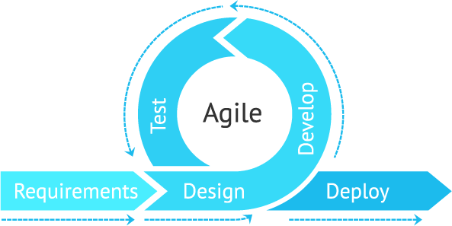In the deployment phase, the requirements or the specification of a computer must have at least Dual Core Processor, with 2gb of RAM and minimum of 150GB HDD. Since the system is offline all of the browsers are accepted except Internet Explorer because it does not support most of the features that come with the system.

Figure 2. Liza Hazevytch Agile Method Model, February 26, 2020

# Methods

Agile technique is an iterative, time-boxed, people-oriented and result-focused software development strategy that incrementally constructs software from the beginning of the project, rather than delivering it all at once towards the end. Requirements, strategies, and outcomes are constantly assessed according to this principle; teams have a natural framework for rapidly adapting to change.

Agile method is increased adaptability and client satisfaction. This method also makes it easy for fixes, increased teamwork, and efficient product deployment. With increased adaptability come the negative of feature, the never-ending addition of requirements of the client. Agile method contains a very specific section of the overall project. Until that section meets the client needs.

# Requirements.

The requirements stage the researcher asserts the company’s problem and objectives. The researcher gathers the information about the problem to identify the goal of the company assuming that the researcher already finalizes the system.

In the requirements phase the researchers conducted an online interview with the client, owner of the AASON trading located in Bacoor City of Cavite through the use of discord. The data gathered by the researchers was use to analyze the problem and for the development of the system. The deliverables of this phase are the interview report and system request.

# Design.

The design stage the researchers plan and prototype the system through the use of pen and notebook after we finalize the design, we created the final output via canva. The researchers were instructed to do prototype of the system to plan and assume what will the system looks.

In the design phase the researchers plan the systems flow through the use of an application through the web which is called draw.io, researchers illustrated the flow of the

system and uses the Entity relationship diagram model to create the flow of the system. The deliverables of this phase are the Use Case diagram, Data Flow Diagram, Contextual Framework, Sequence Diagram, Entity Relation Diagram.

# Develop.

The develop stage is the development of the system via coding in accordance with the planned design of the researchers. This stage is about writing code and converting design documentation into the actual software.

The researcher started to code the planned design system. The researcher used the Hypertext Markup Language and CSS to build the web browser and the design, MySQL, XAMPP for the database of the inventory, stocks, attendance, sales report of the company, Php for the connection of the Html and MySQL to build the system finally. The deliverable of this phase is the actual system that has been developed by the researchers.

# Test.

The test stage, the researchers are now testing the system to make it available to deploy and look for occurring bugs and possible malfunctions within the system. In this stage the researchers are finalizing the system for the deployment and releasing of the system to the client/company.

In this phase the researchers tested all operations of the systems such as recording biometrics through the use of fingerprint scanning for the employee’s attendance, making an update and view of the stock in the inventory, recording of the sales and the income

every week. The deliverables of this phase are the modification of design, debugging of functions, implementation of the additional request of the client.

# Deploy.

The deploy stage, the researchers are now ready to deploy the well-developed system that will hopefully meet the needs of the said client/company. The researchers update the client that the system is now ready to use for the company’s day to day transaction.

In the deploy phase, the researchers install the system to the client’s compatible computer. The researchers test the system with the client’s device, and look for some feedback of the client for further development of the system. The deliverable of this phase is the finalize and maintained system of the company created by the researchers.

# Annotated Bibliography

Serhii Ziukov (June 2015).

A Literature Review on Models of Inventory Management under Uncertainty [https://pdfs.semanticscholar.org/0272/2cb8911cc7c738002760b3b75de844c04702](https://pdfs.semanticscholar.org/0272/2cb8911cc7c738002760b3b75de844c04702.pdf?fbclid=IwAR0PabyxTZNgi8LcuO0h3SLyI33-CMxqeThrLwO940566ZkUqjqefoUK3KE)

[.pdf?fbclid=IwAR0PabyxTZNgi8LcuO0h3SLyI33-](https://pdfs.semanticscholar.org/0272/2cb8911cc7c738002760b3b75de844c04702.pdf?fbclid=IwAR0PabyxTZNgi8LcuO0h3SLyI33-CMxqeThrLwO940566ZkUqjqefoUK3KE)

[CMxqeThrLwO940566ZkUqjqefoUK3KE](https://pdfs.semanticscholar.org/0272/2cb8911cc7c738002760b3b75de844c04702.pdf?fbclid=IwAR0PabyxTZNgi8LcuO0h3SLyI33-CMxqeThrLwO940566ZkUqjqefoUK3KE)

David Ingram (2017).

General Objectives of Sales and Inventory System.

[https://bizfluent.com/info-7970317-general-objectives-sales-inventory-](https://bizfluent.com/info-7970317-general-objectives-sales-inventory-systems.html)

[systems.html](https://bizfluent.com/info-7970317-general-objectives-sales-inventory-systems.html)

Sandra Johnson (September 26, 2017). Objectives of the POS System.

<https://bizfluent.com/info-8432075-objectives-pos-system.html>

Kirk Thomason (2017).

Accounting Methods for a Small Retail Store

<https://bizfluent.com/info-8102472-accounting-methods-small-retail-store.html>

Osmond Vitez (2017).

Set-up Master Inventory List

<https://bizfluent.com/how-6943407-set-inventory-item-numbering-system.html>

Cliff Holt (2015).

The TCGRx Beacon Pharmacy Inventory Management System. United States [http://www.rxinsider.com/case_studies/TCGRx_CaseStudy_20waysFall17.pdf?fb](http://www.rxinsider.com/case_studies/TCGRx_CaseStudy_20waysFall17.pdf?fbclid=IwAR2zaKmBKL95YzRQqibuhP-poSysgSSjv0b3q5kVP7gi9s1s7lNRmh52bx8)

[clid=IwAR2zaKmBKL95YzRQqibuhP-](http://www.rxinsider.com/case_studies/TCGRx_CaseStudy_20waysFall17.pdf?fbclid=IwAR2zaKmBKL95YzRQqibuhP-poSysgSSjv0b3q5kVP7gi9s1s7lNRmh52bx8)

[poSysgSSjv0b3q5kVP7gi9s1s7lNRmh52bx8](http://www.rxinsider.com/case_studies/TCGRx_CaseStudy_20waysFall17.pdf?fbclid=IwAR2zaKmBKL95YzRQqibuhP-poSysgSSjv0b3q5kVP7gi9s1s7lNRmh52bx8)

Patrick Mahony (2020).

Inventory Management Case Study. <https://www.abr.com/author/patrick-mahony/>

Ariel O. Abriel, Erbie N. Maglangit, Rolly B. Abellanosa (2013).

Online Supply Inventory System. Bukidnon State University, Alubijid External Studies Center

[https://www.slideshare.net/rokista/online-supply-inventory-](https://www.slideshare.net/rokista/online-supply-inventory-system?fbclid=IwAR1Mu_AHAeSPWmclv1AuGwz_qOZXNBfsko7xrOsczlMe5aGkgqtFecB5Tro)

[system?fbclid=IwAR1Mu_AHAeSPWmclv1AuGwz_qOZXNBfsko7xrOsczlMe5](https://www.slideshare.net/rokista/online-supply-inventory-system?fbclid=IwAR1Mu_AHAeSPWmclv1AuGwz_qOZXNBfsko7xrOsczlMe5aGkgqtFecB5Tro)

[aGkgqtFecB5Tro](https://www.slideshare.net/rokista/online-supply-inventory-system?fbclid=IwAR1Mu_AHAeSPWmclv1AuGwz_qOZXNBfsko7xrOsczlMe5aGkgqtFecB5Tro)

Liza Hazevytch (February 26, 2020).

Agile Advantages for Software Development and Your Business

<https://devcom.com/tech-blog/agile-advantages-for-business/>

# APPENDICES

**Appendix A SYSTEM REQUEST**

**Project Title**

Inventory System for AASON Trading

# Company Background

The Company started as a dealer of an American Multinational Beverage Corporation, known as Coca-Cola. Later on, the Company decided to add other variant of beverage products from other companies such as Pepsi Philippines, Rc Cola Philippines, and ARC Refreshment in order to supply a wide variety of beverage products to the loyal customers that patronize the Company’s products and also in order to keep the loyal customers during the first year of the Company. During the early years of the AASON Trading Company, it was only located in Cavite in the City of Bacoor, but due the growing number of clients, customers and the growing demand of the Company’s products, It’s added two more branches located in Las Pinas, Manila and Imus, Cavite in order to meet the increase in demand of the products

# Problem Background

The Company client is currently struggling in its inventory operation this is because they are still operating on “mano-mano” or by simply writing their transactions manually in a notebook with a pen to record their day-to-day transactions.

|  |  |
| --- | --- |
| Business Needs | The client aims to have a faster, easier and modern way of recording their day-to-day transactions. |

|  |  |
| --- | --- |
| Business Requirements | * Report of Incoming/Outgoing of products * Monitored Attendance of the Employee * Monthly End Report * Total Inventory Report * Product Inventory:   + Pepsi   + Coca-Cola   + ARC Refreshments |
| Business Value | We can help the clients by making a system that will answer or solve their problem about manual booking their transactions. Also, the system will help the clients to monitor data and informations of their incoming and outcoming product. System includes the prices and availability of the products. |
| Special Issues or Constraints | * Attendance of the employee, to track down the time in, time out, and absences of the employee. * Inventory of the product to make sure that the outcoming and incoming data of the product is accurate and organize. * Updated Price and Availability of the product * Monthly End Report, record the sales and expenses of the company in a monthly period. * Total Inventory Report, record of incoming and outgoing of a product in a monthly period. |

|  |  |
| --- | --- |
| Project Roles | Villanueva, Jaime III C., Mesa, Lawrence M., Ronquillo, Mark R. are the members of this group and also the system programmers in charge to make and provide the system to the client. |

Project Proponents

# Member A: Villanueva, Jaime III C. Member B: Mesa, Lawrence M. Member C: Ronquillo, Mark R.

**Appendix B**

**INTERVIEW REPORT**

**Person Interviewed:** Maria Armie Aguilar and Jose Leosidro Bartolome the owner of AASON Trading Company

**Interviewer:** Villanueva, Jaime III C., Ronquillo, Mark R. and Mesa, Lawrence M.

# Purpose of the Interview:

* To gather information about the business of the client.
* To know what kind of struggles they experiencing in a day-to-day basis.
* To know the background of the business.

# Summary of the Interview:

* **Reasons of the Interview**

**-**The AASON Trading Company requested our group to come up a system with this kind of features such as: Monitoring the time in and time out as well as the absences of the employees. The price and availability of the products. The inventory of incoming and outgoing of products. Lastly, the monthly end report of sales and incoming/outgoing also the total inventory report of products in a monthly period.

# Problem of the client

-The main problem of the Company client is that the business is expanding without a much more reliable, easy to use and faster system to record their day-to- day transactions.

# Benefit of the System

**-**The benefit of the system is that the manual way of recording a transaction and attendance of the employees, will turn into a systematic and organize way. The system will help the business operate faster and easier.

# Appendix C

Figure 3. Entity Relationship Model

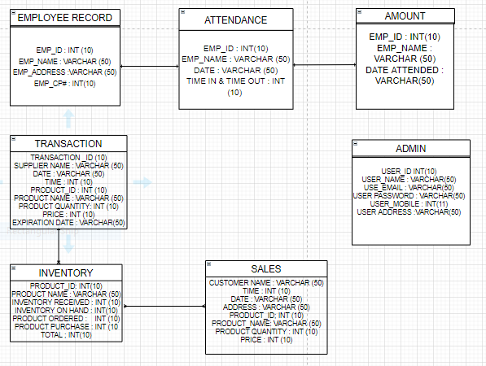

# Appendix D

Figure 4. Data Flow Diagram Model

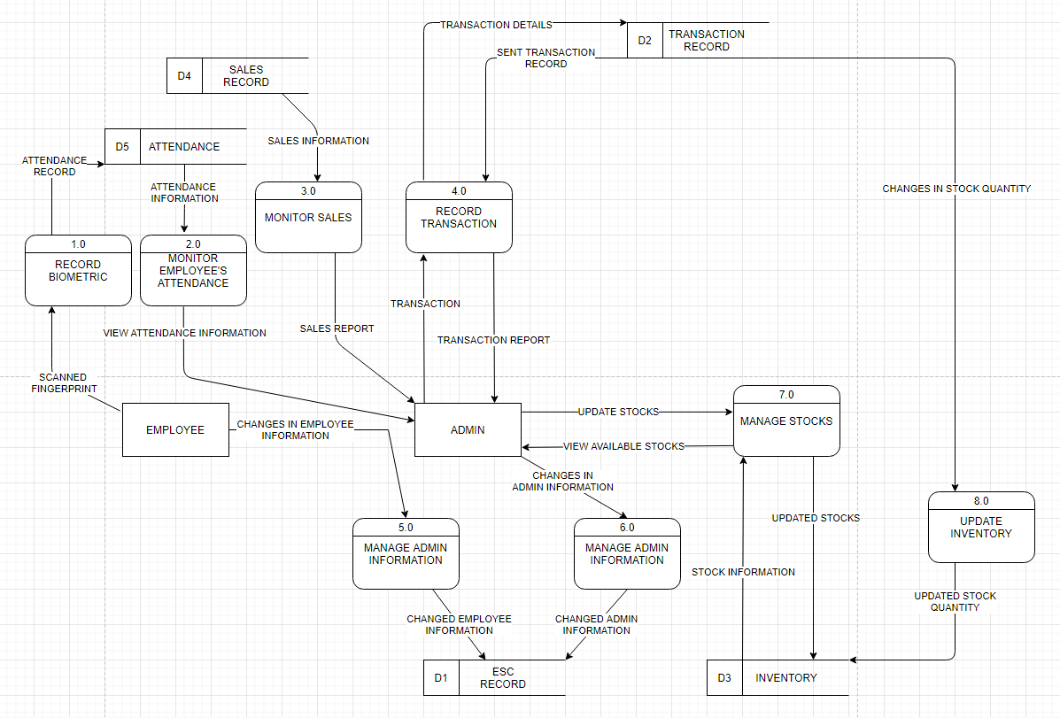

# Appendix E

Figure 5. Contextual Framework

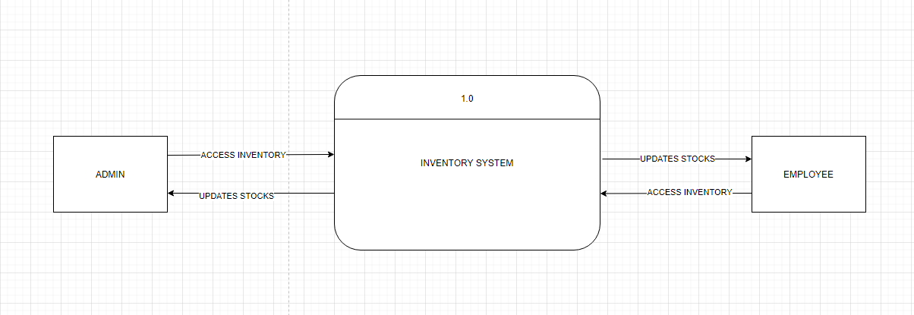

# Appendix F

Figure 6. Use Case Diagram

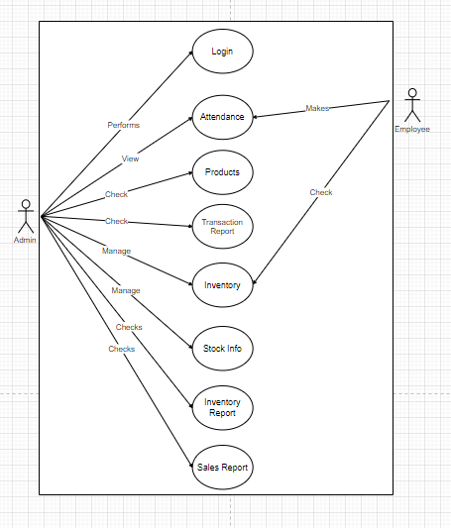

# Appendix G

Figure 7. Sequence Diagram

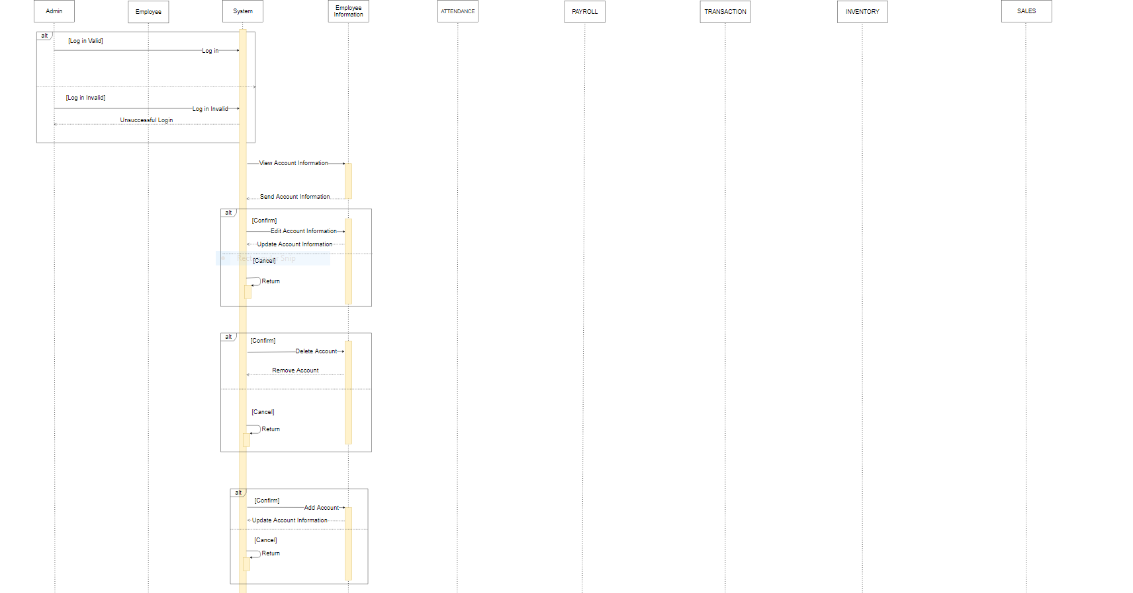

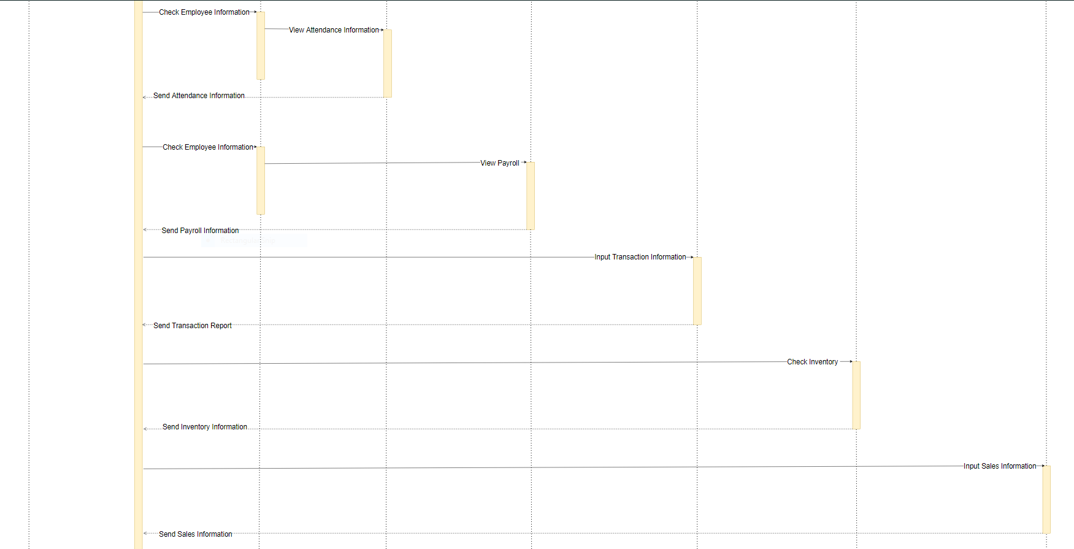

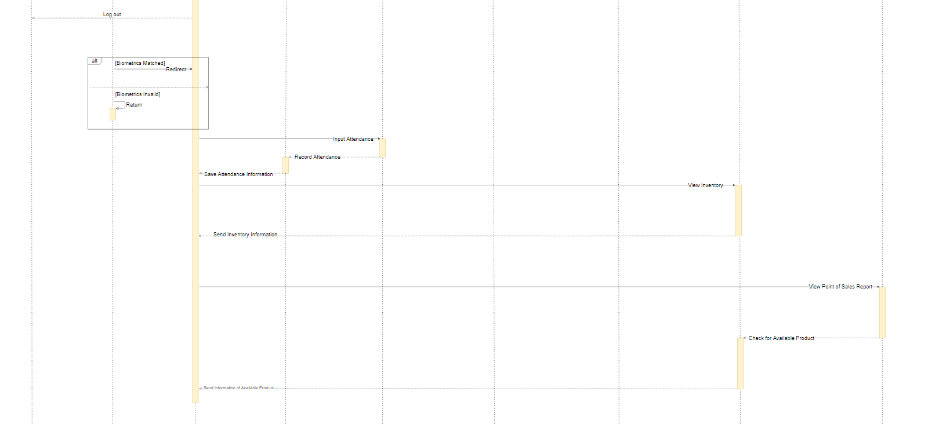

# Appendix H

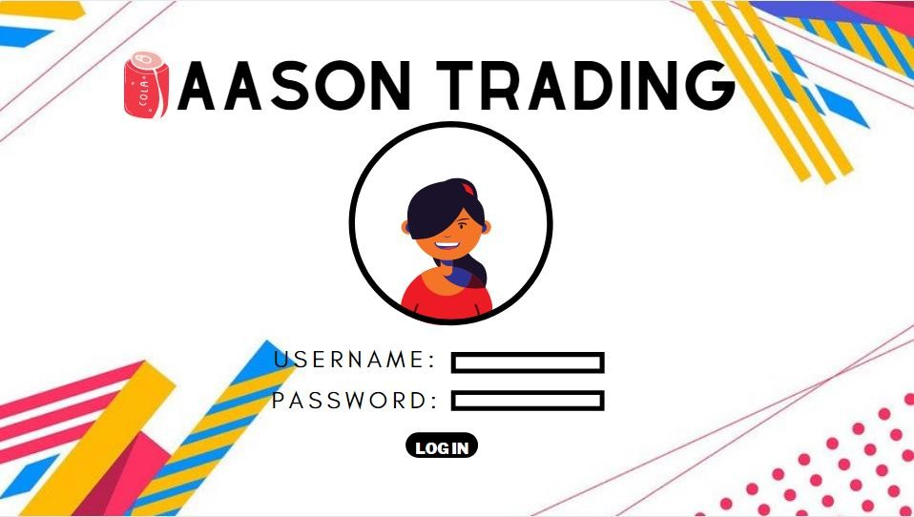Figure 8. Log in Home Page Admin

Figure 9. Log in Failed Page

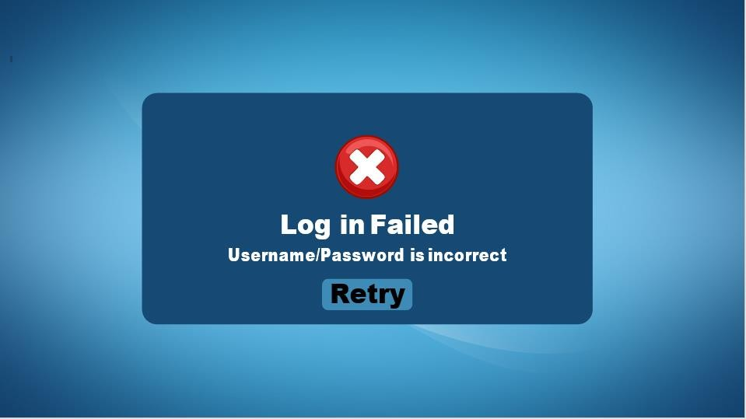

Figure 10. Biometrics Page Employee



Figure 11. Attendance Confirmation

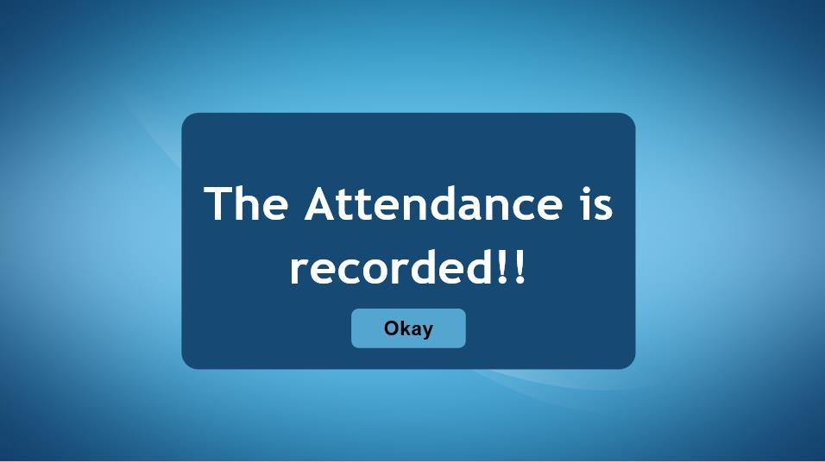

Figure 12. Home Page Employee

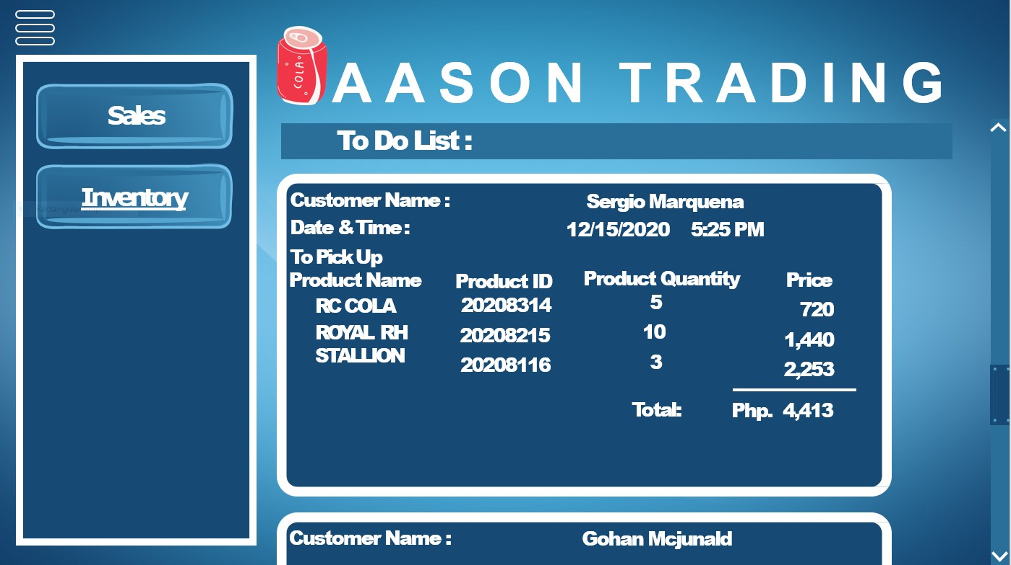

Figure 13. Inventory Manager Page Employee

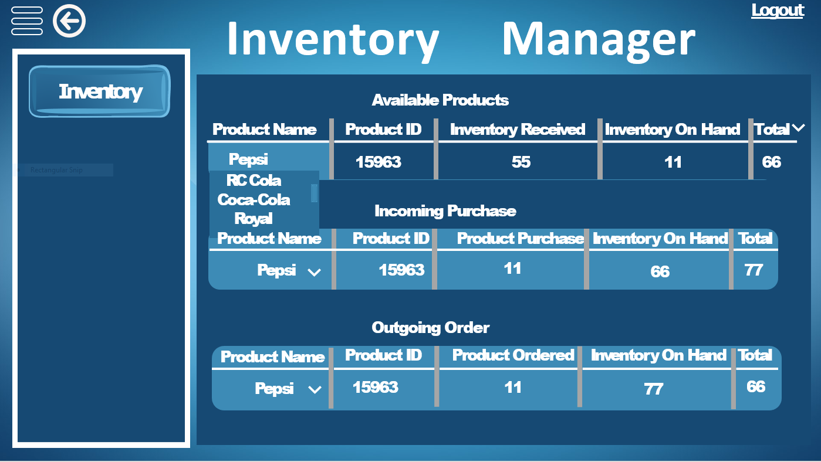

Figure 14. Inventory Manger Dropdown Page

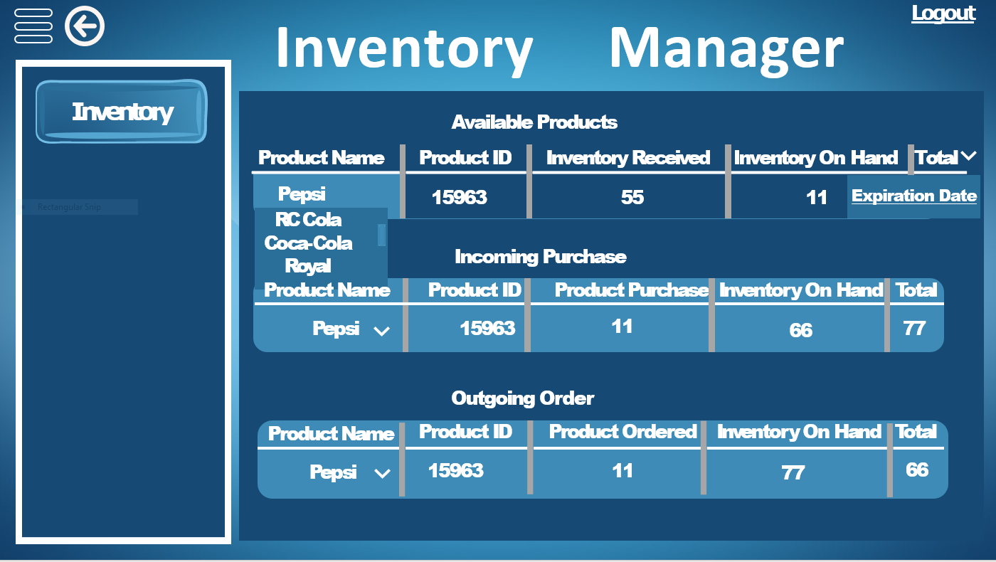

Figure 15. Expiration Date Page

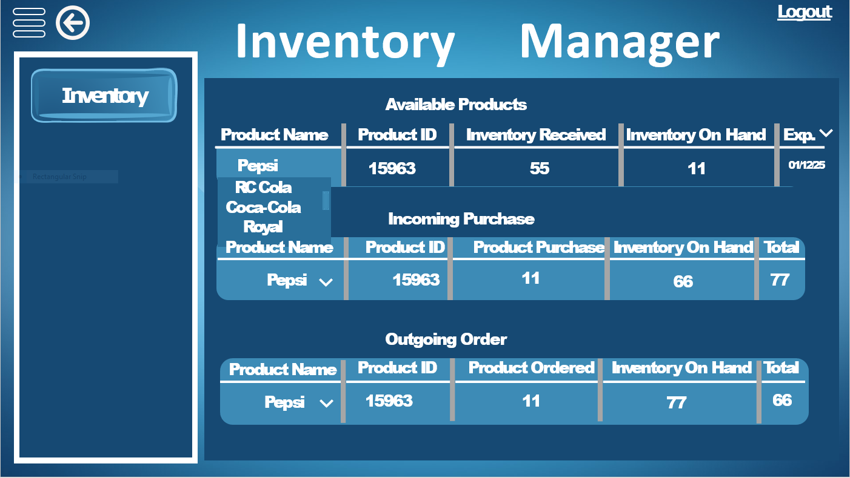

Figure 16. Total Page

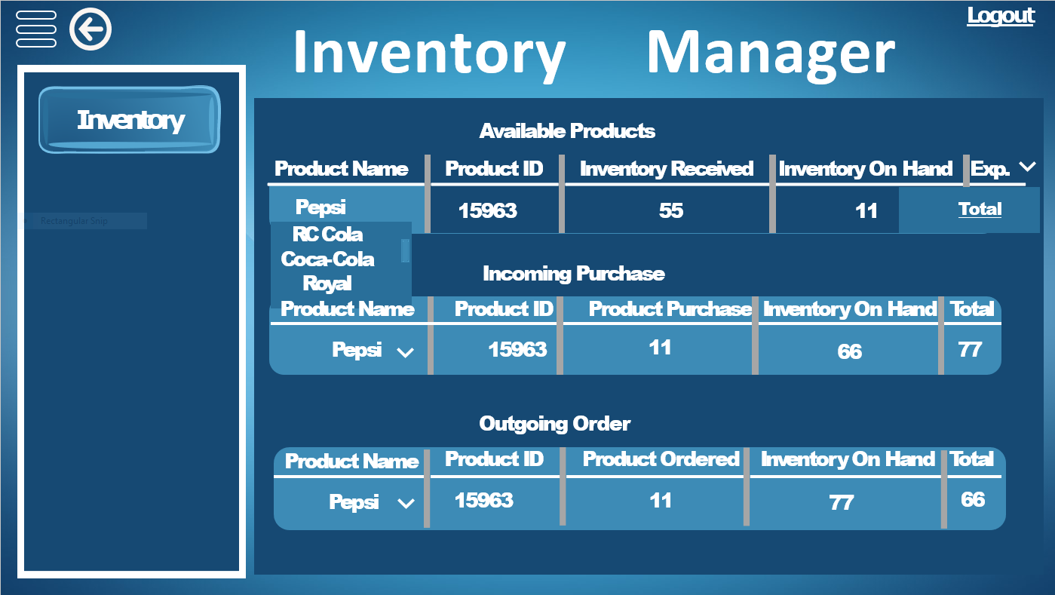

Figure 17. Home Page Employee

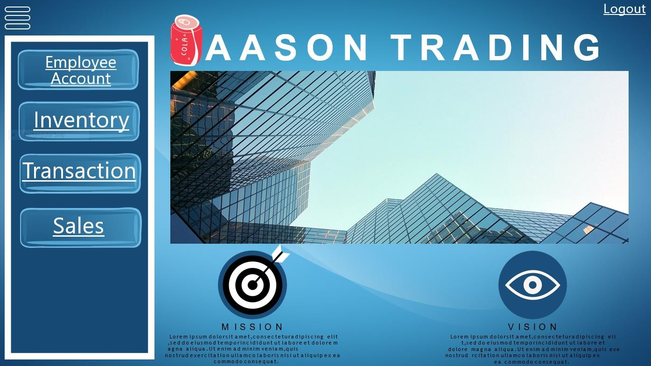

Figure 18. Employee Account Page

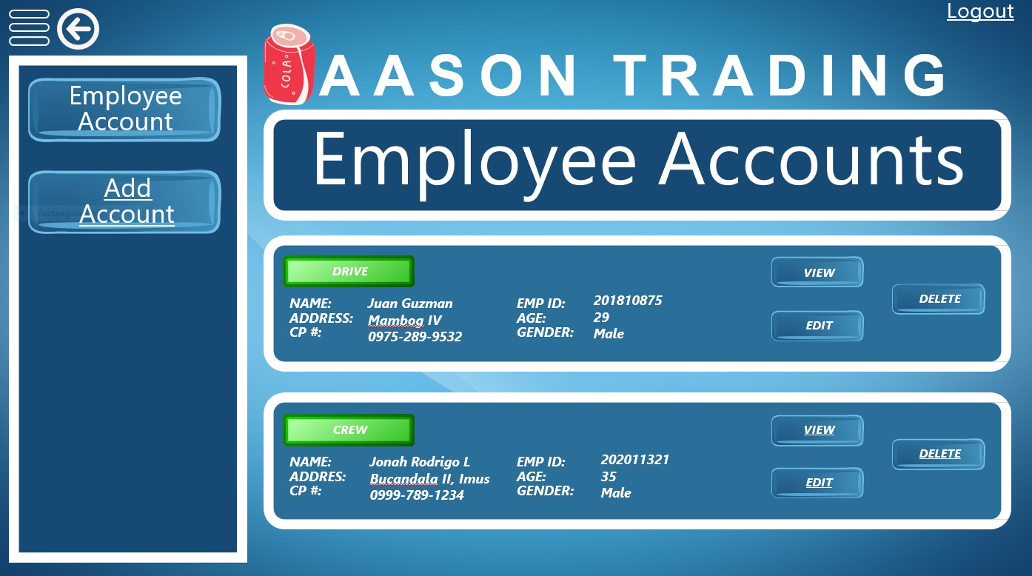

Figure 19. View Employee Account Page

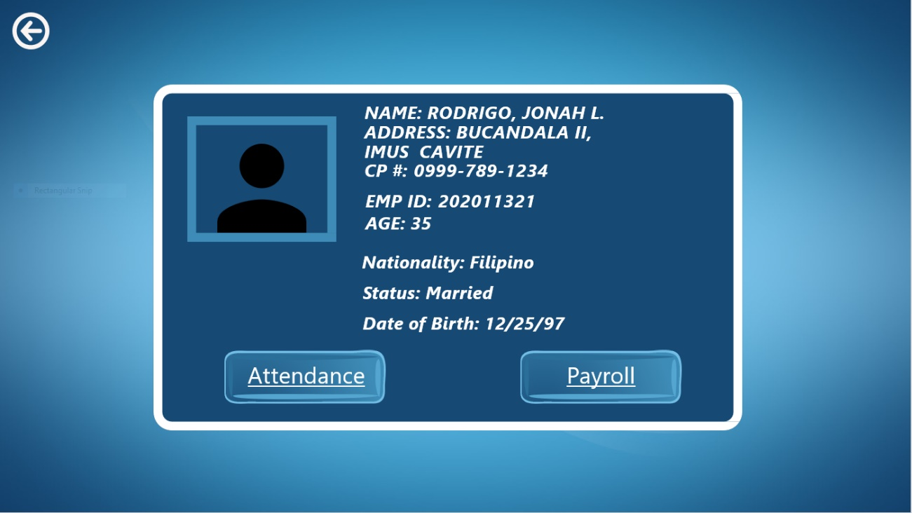

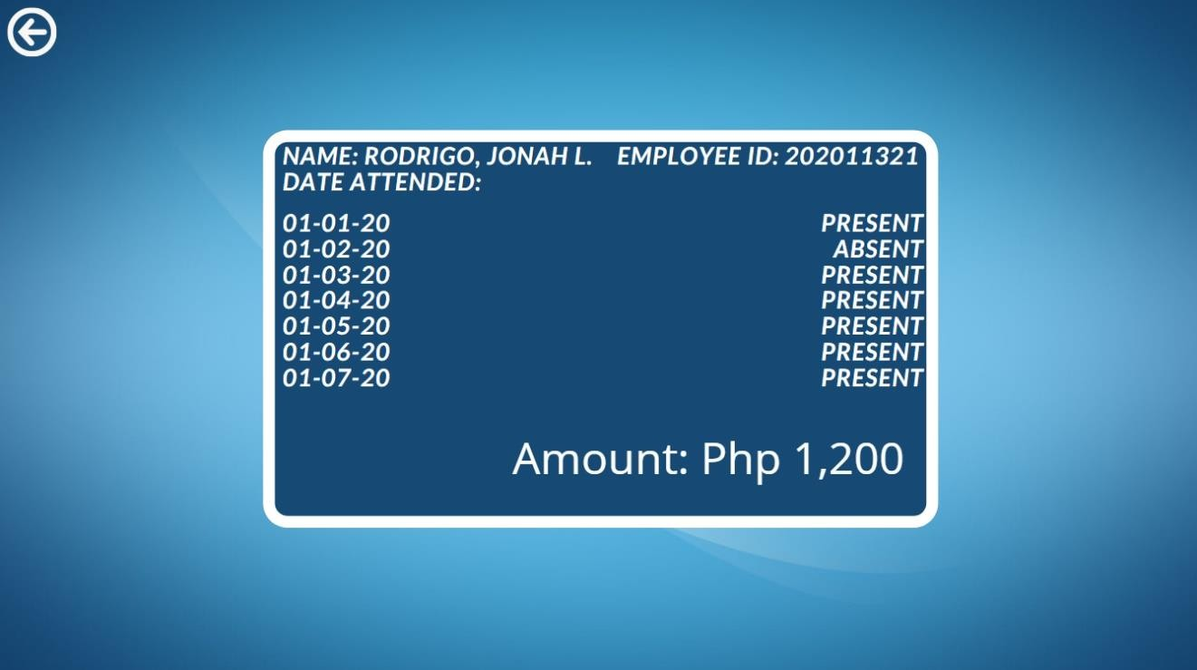

Figure 20. Attendance Page

Figure 21. Payroll Page

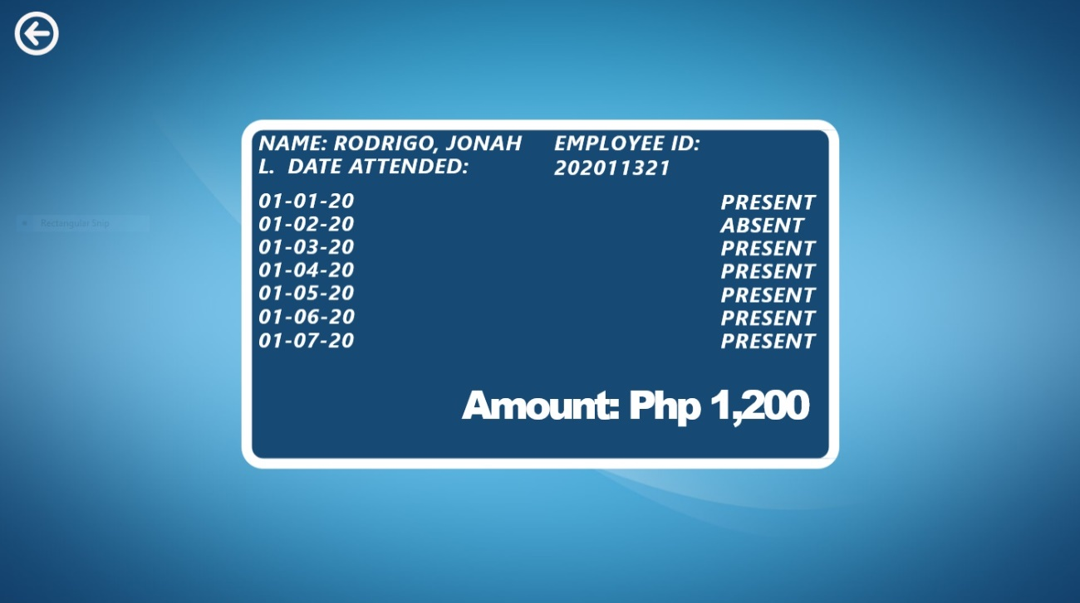

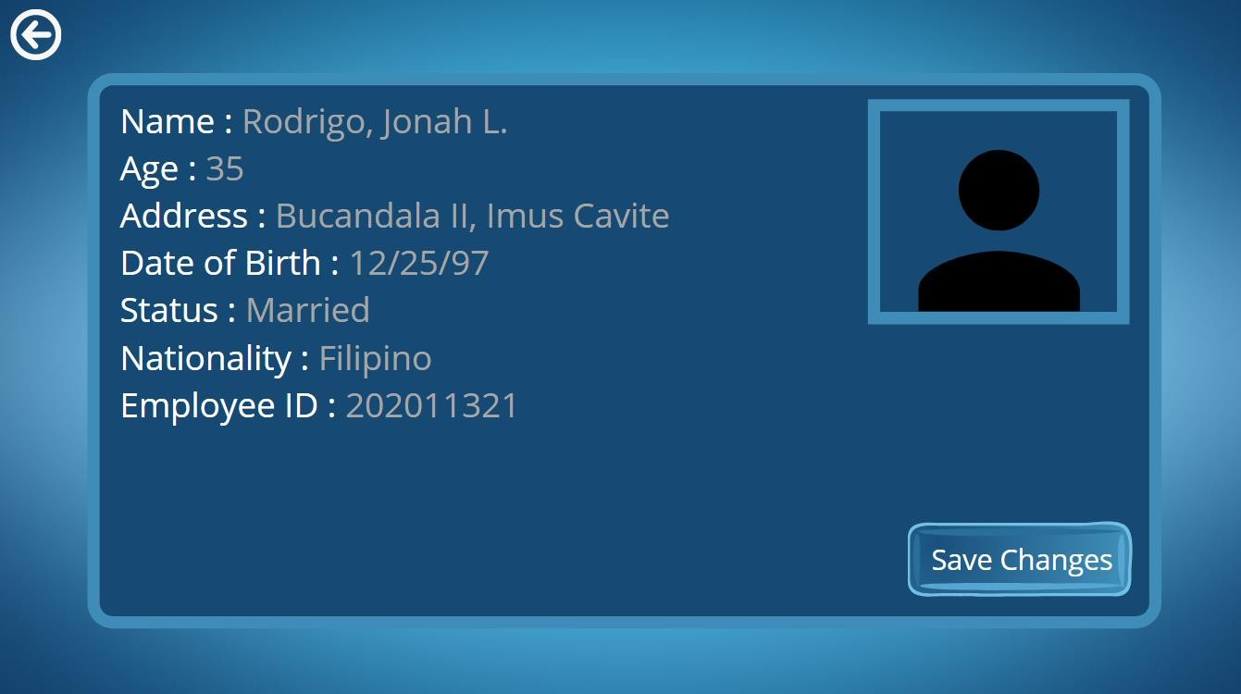Figure 22. Edit Employee Account Button Page

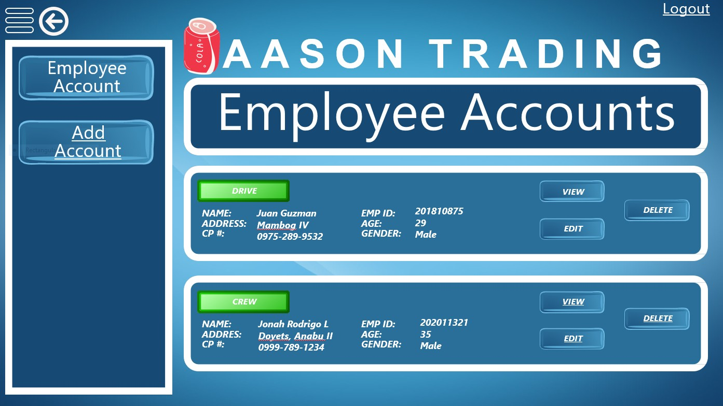Figure 23. Changed Employee Information Page

Figure 24. Delete Employee Confirmation Page

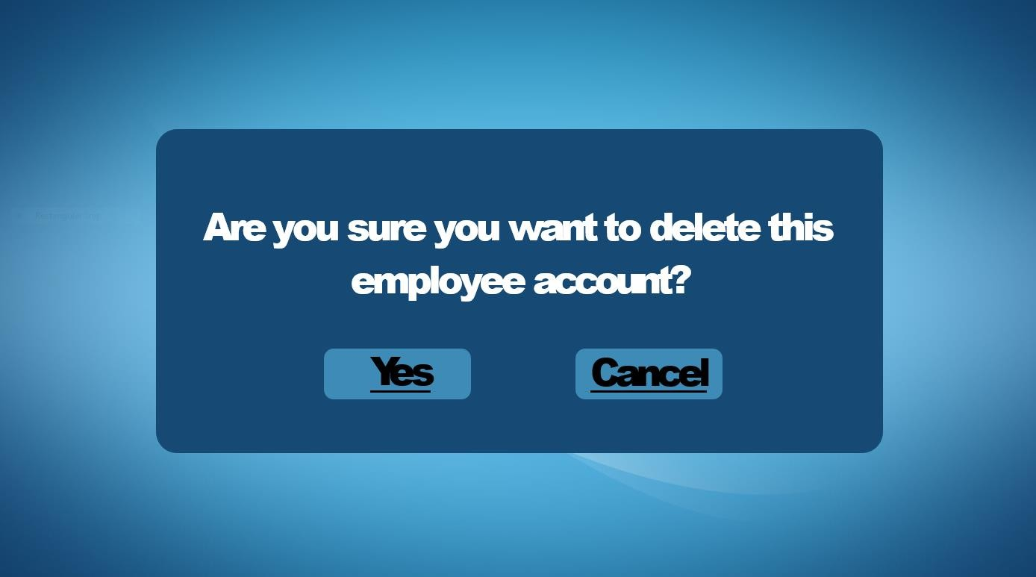

Figure 25. Inventory Manager Page Admin

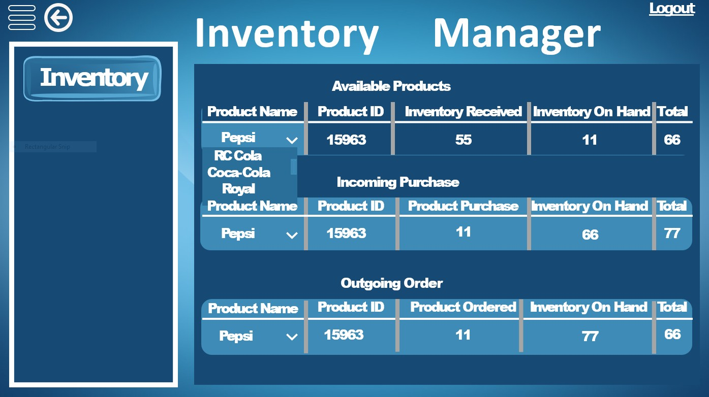

Figure 26. Transaction Page

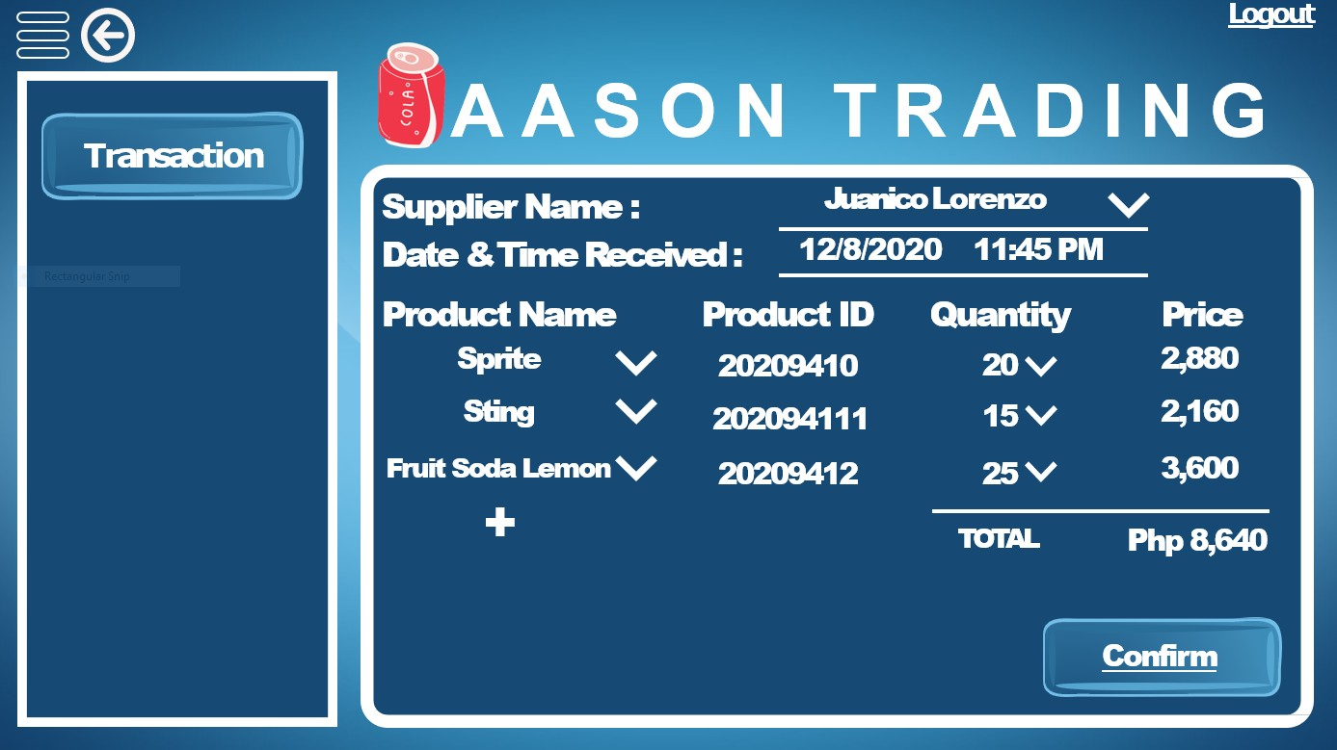

Figure 27. Transaction Confirmation Page

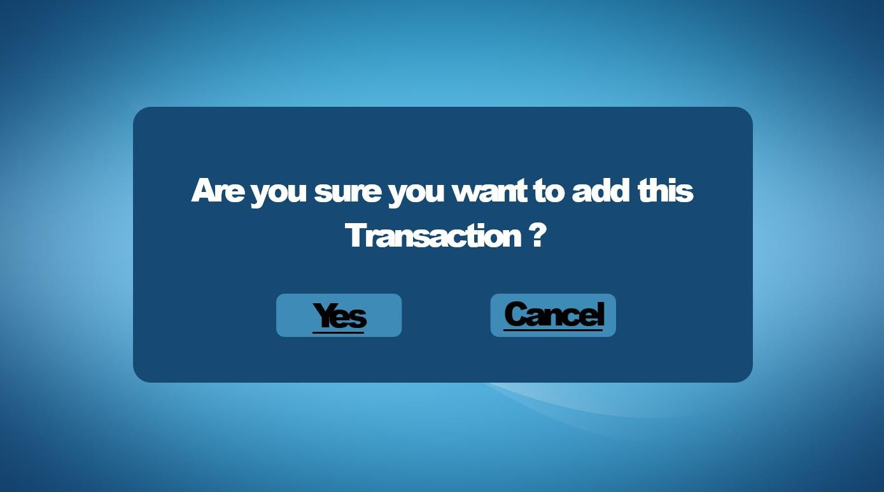

Figure 28. Transaction History Page

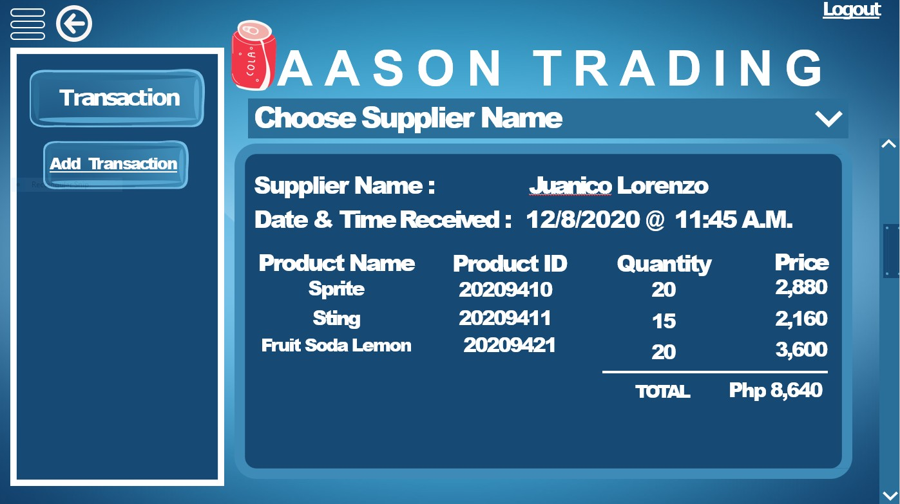

Figure 29. Add Transaction Page

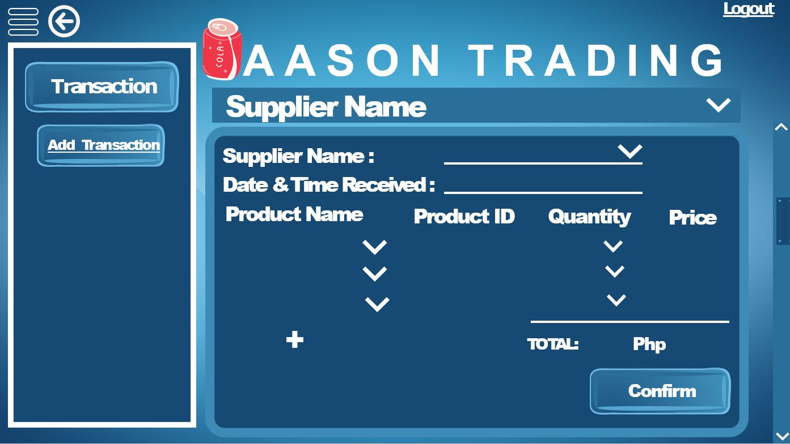

Figure 30. Supplier Name Dropdown Page

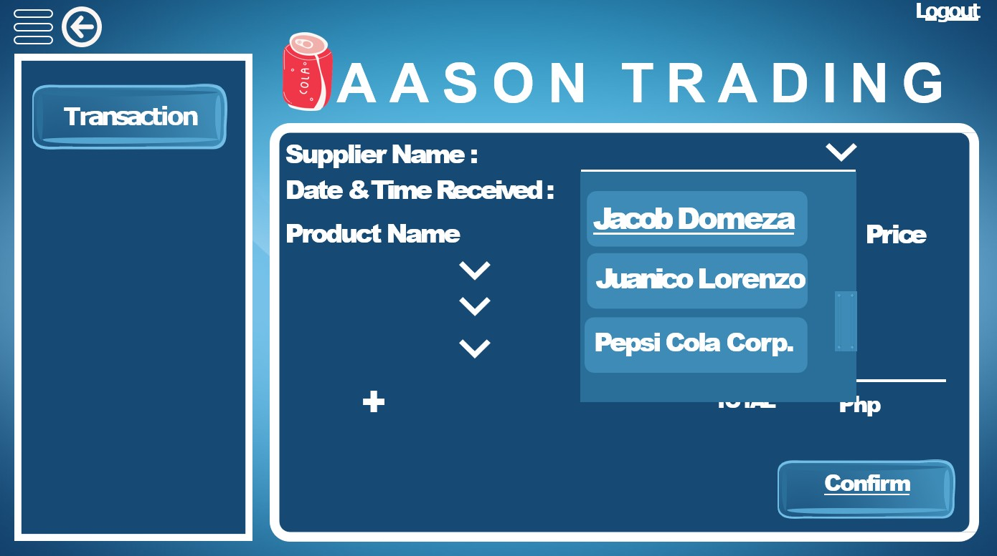

Figure 31. Supplier Name Picked Page

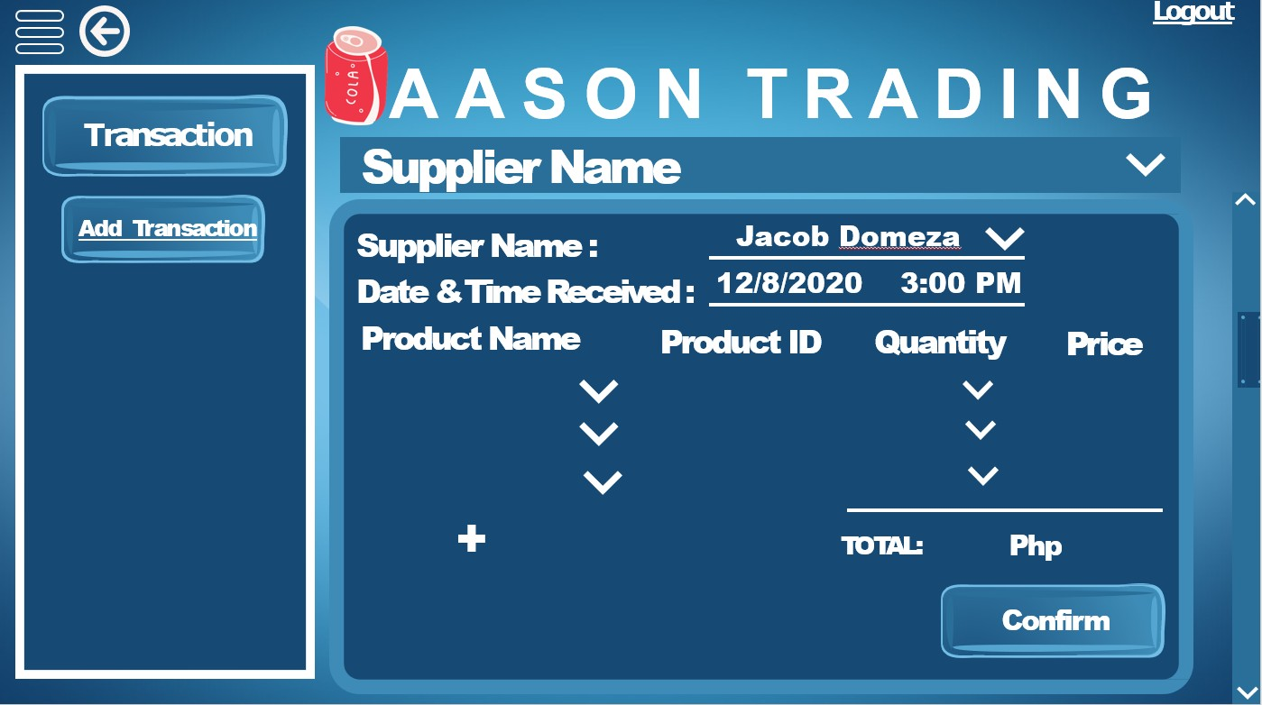

Figure 32. Product Name Drop Down Page

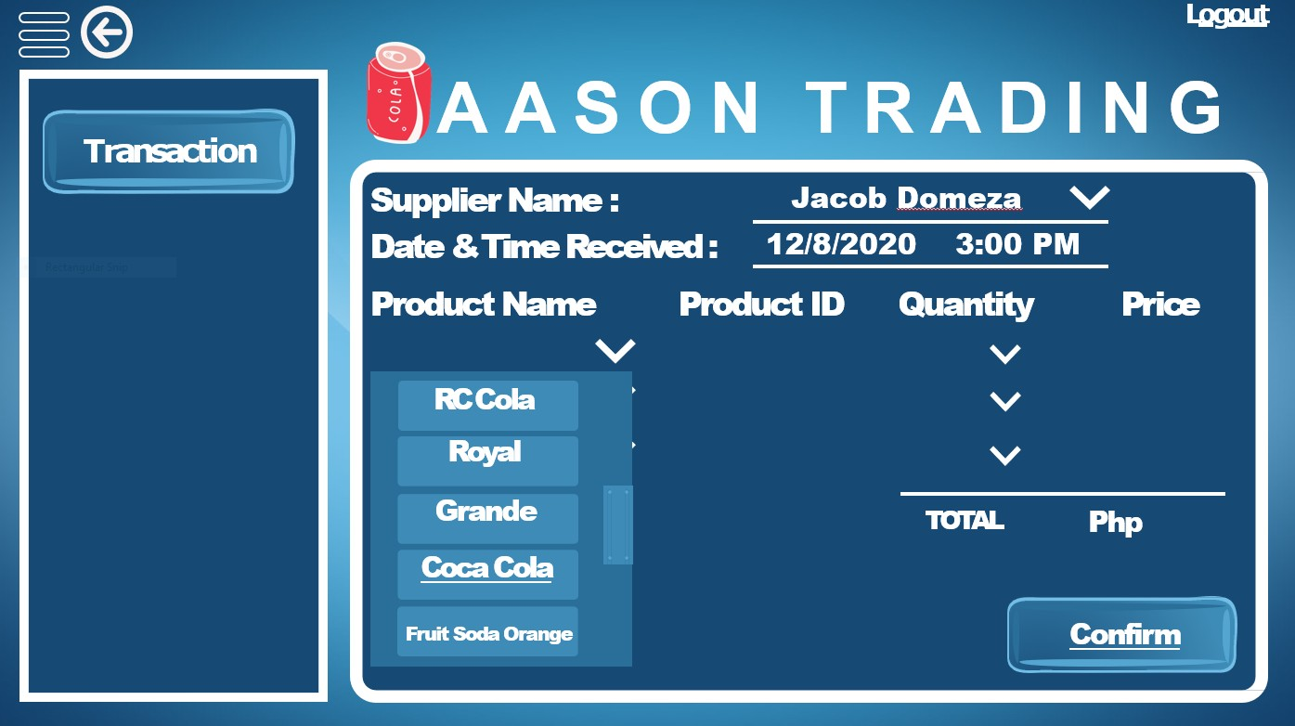

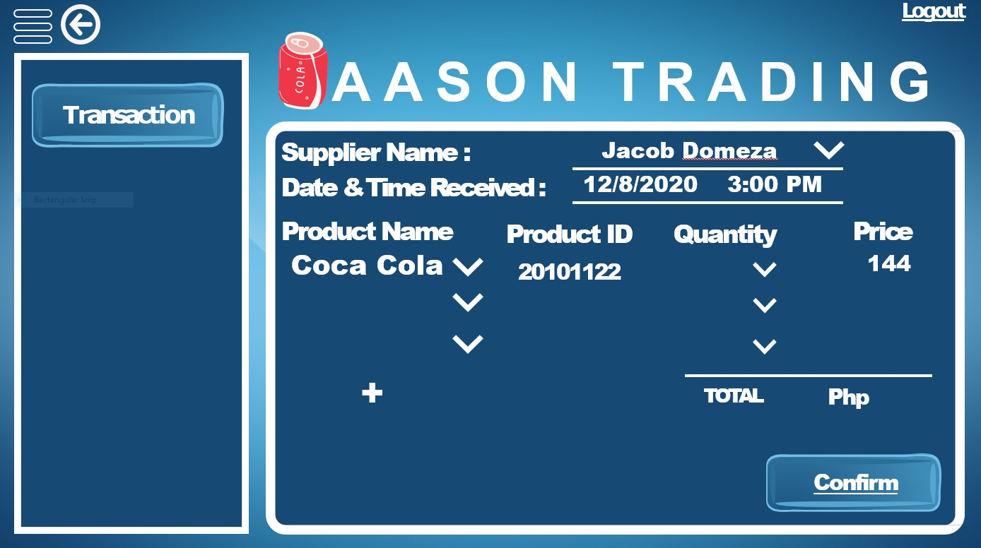Figure 33. Product Picked Page

Figure 34. Quantity Drop Down Page

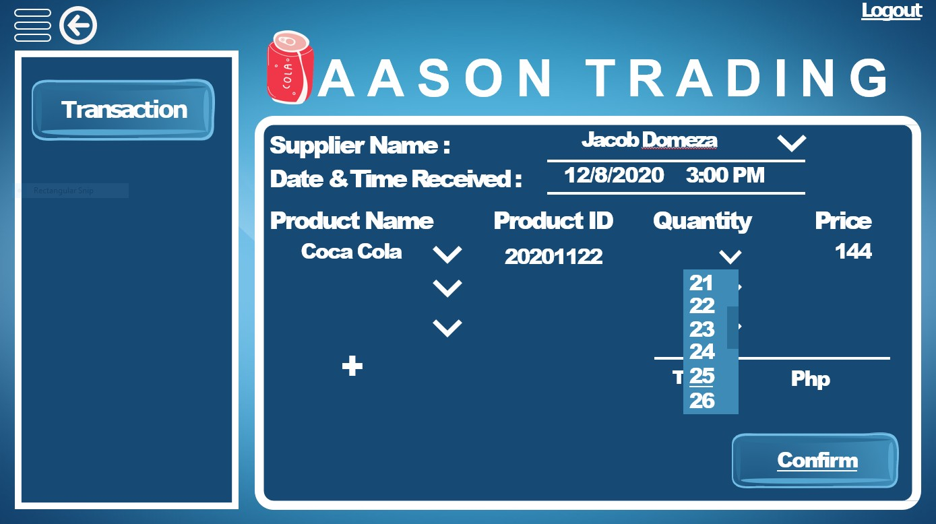

Figure 35. Quantity Picked Page

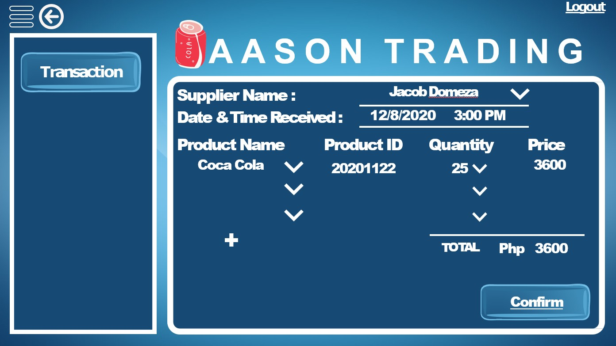

Figure 36. Updated Transaction History Page

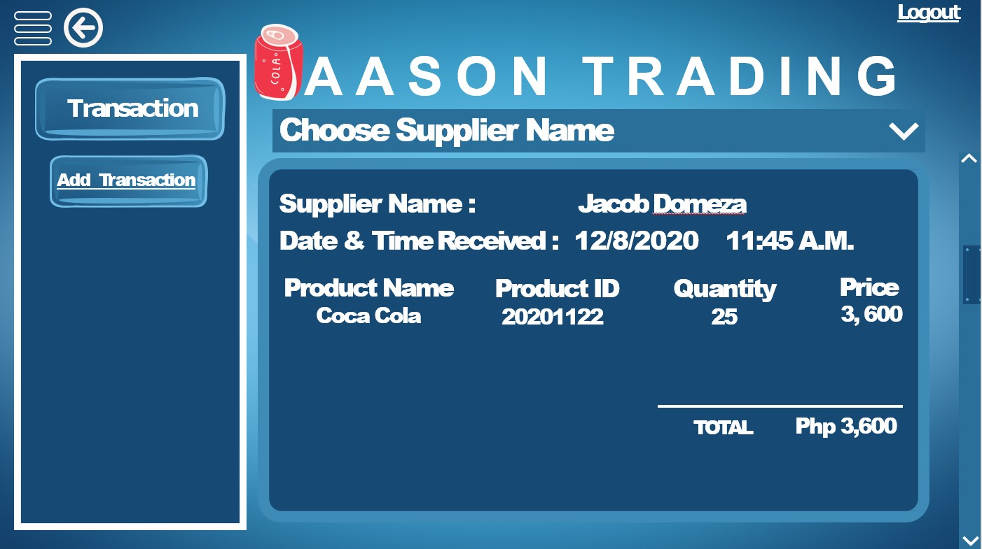

Figure 37. Choose Supplier Name Dropdown Page

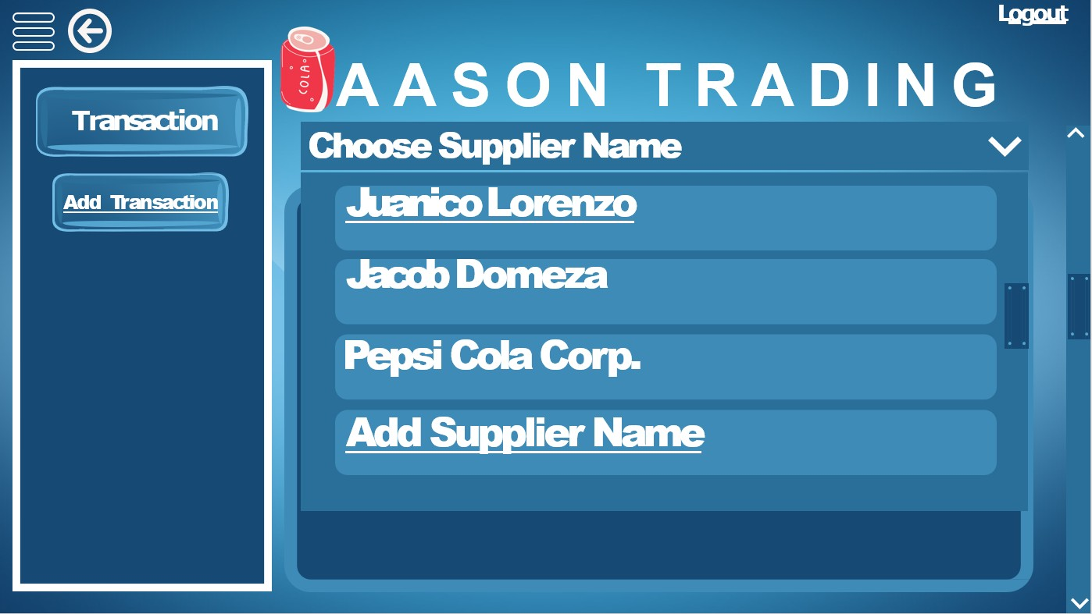

Figure 38. Add Supplier Name Page

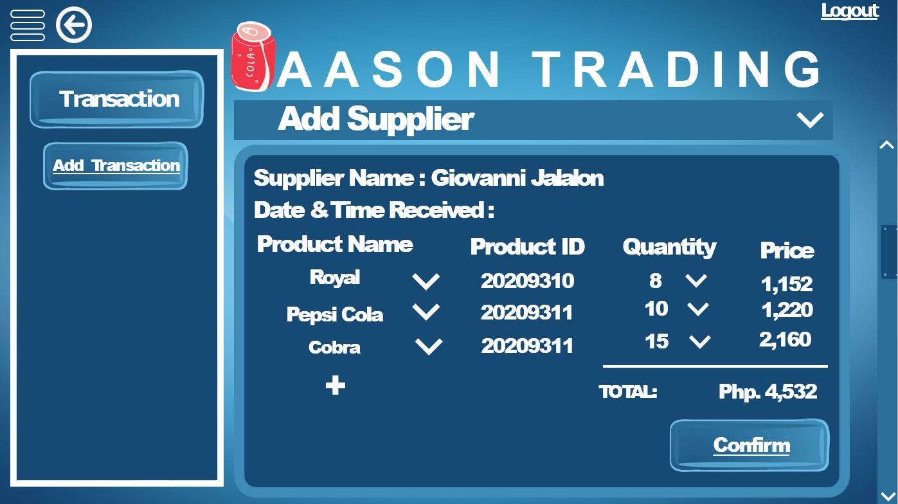

Figure 39. Updated Transaction History Page

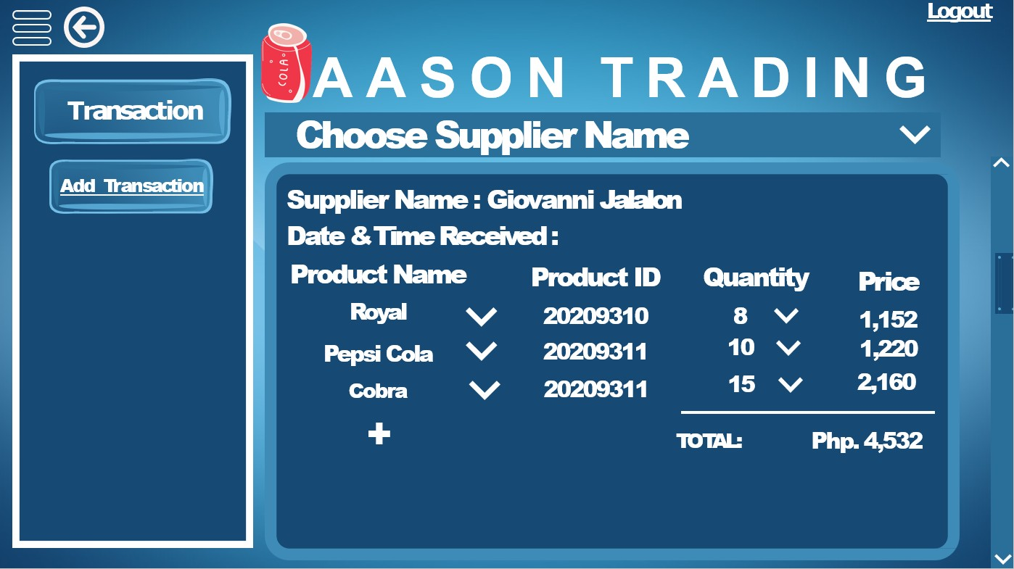

Figure 40. Real Time Record of Sales Report Page

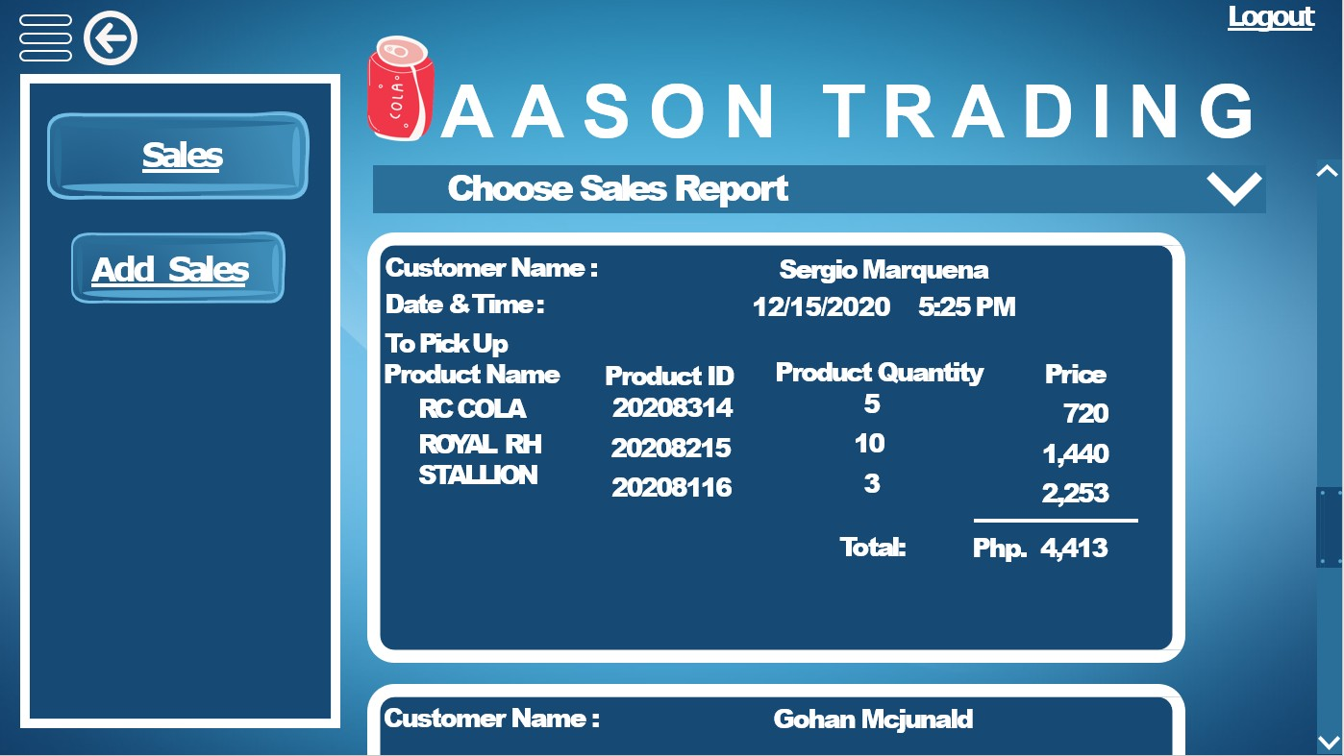

Figure 41. Add Sales Page

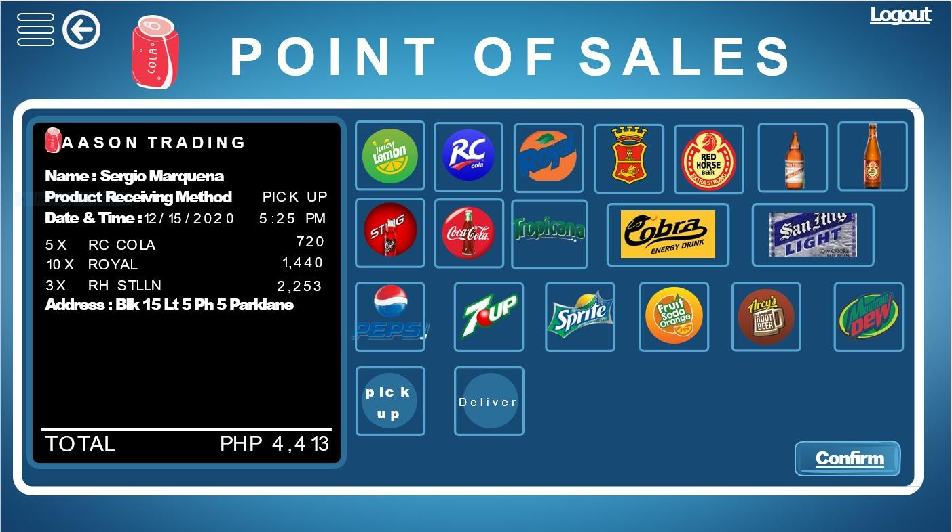

Figure 42. Add Sales Page

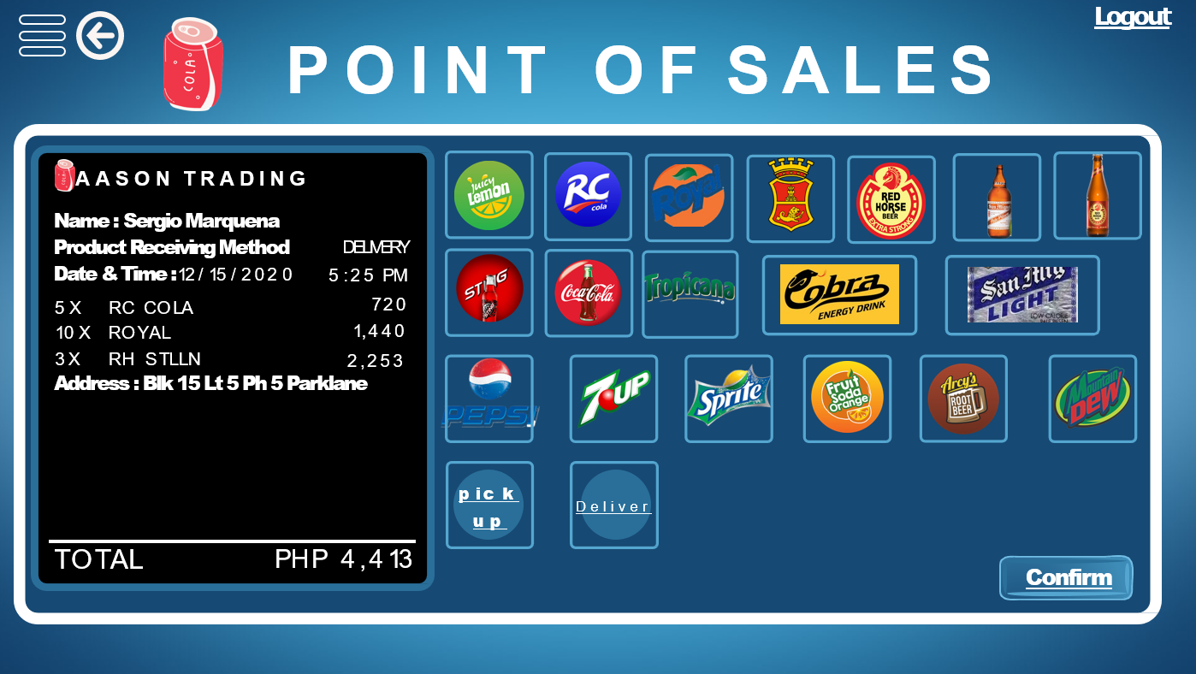

Figure 43. Add Sales Page

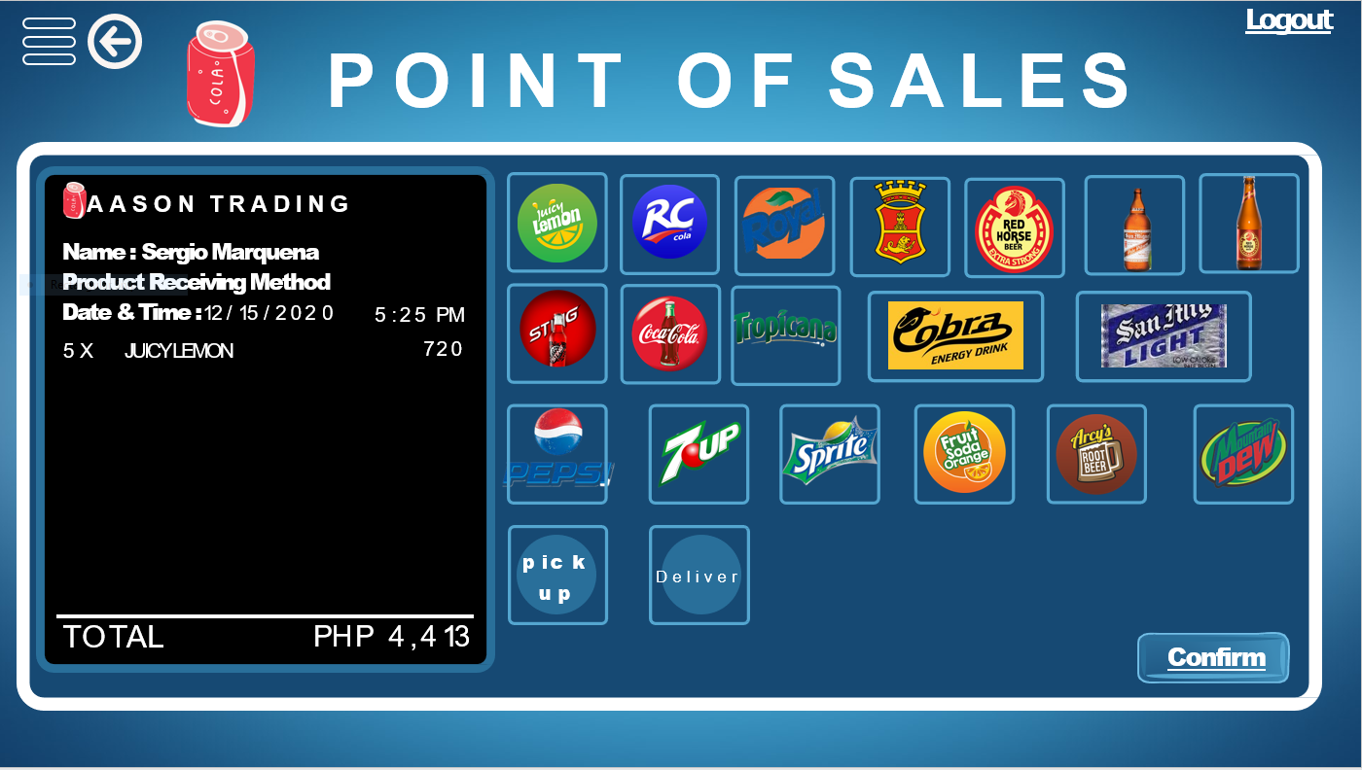

Figure 44. Add Sales Page

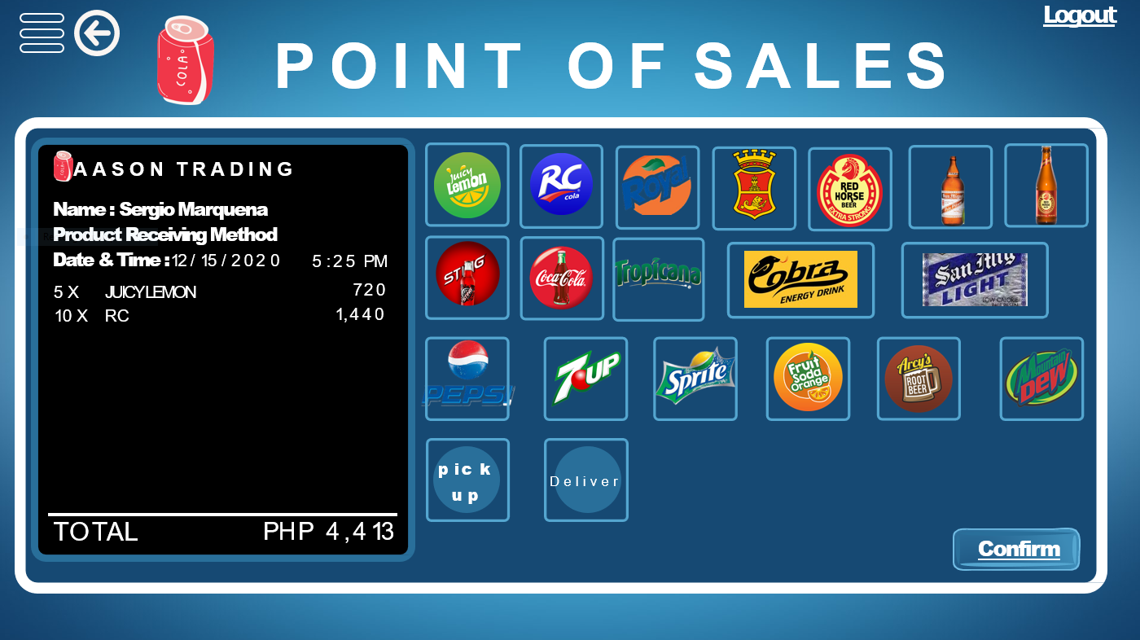

Figure 45. Add Sales Page

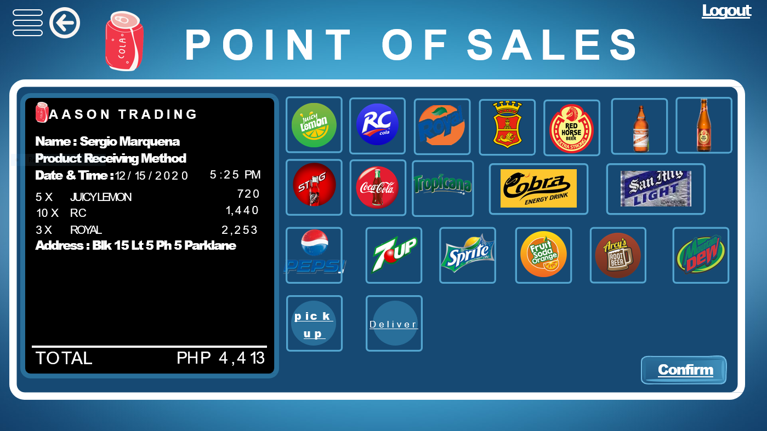

Figure 46. Add Sales Page

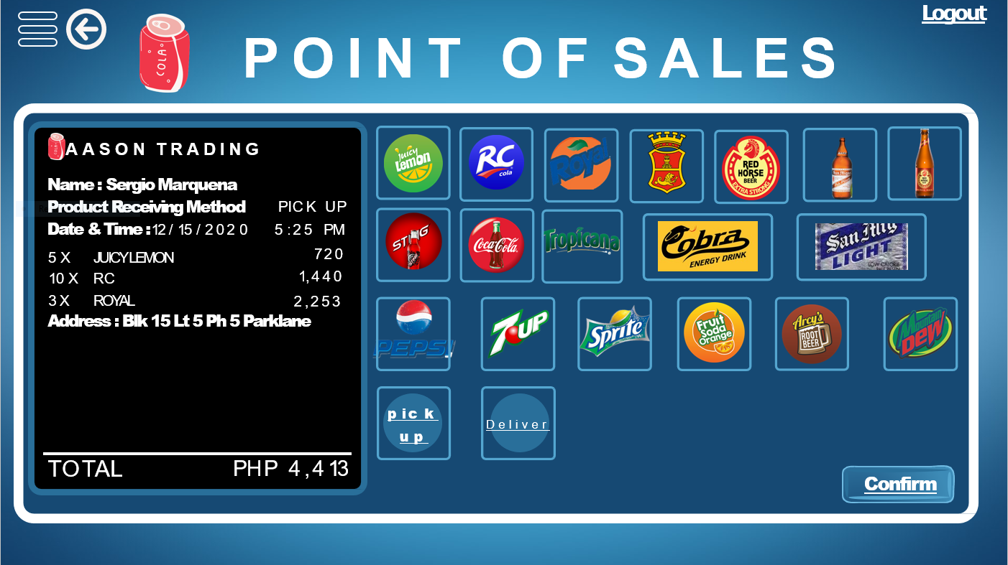

Figure 47. Add Sales Page

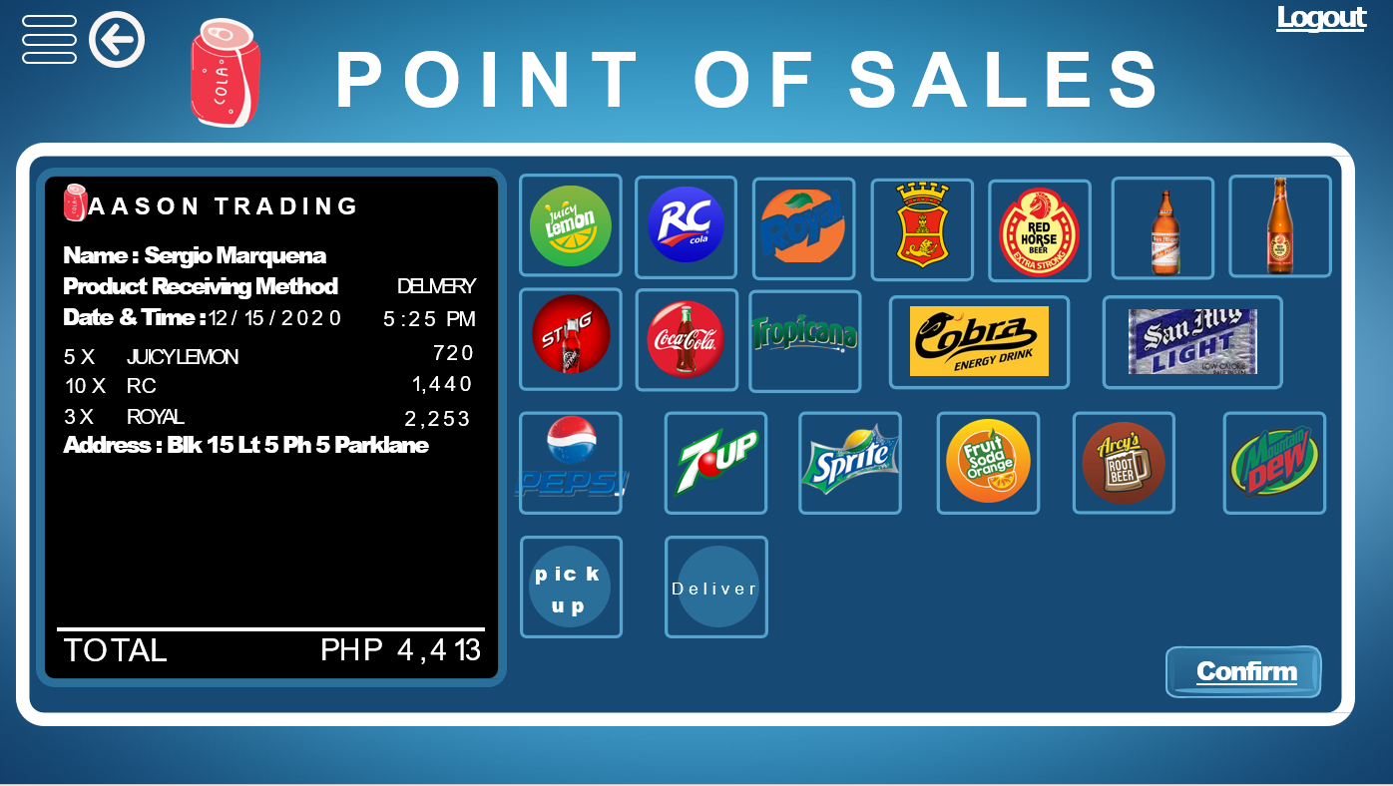

Figure 48. Add Sales Page

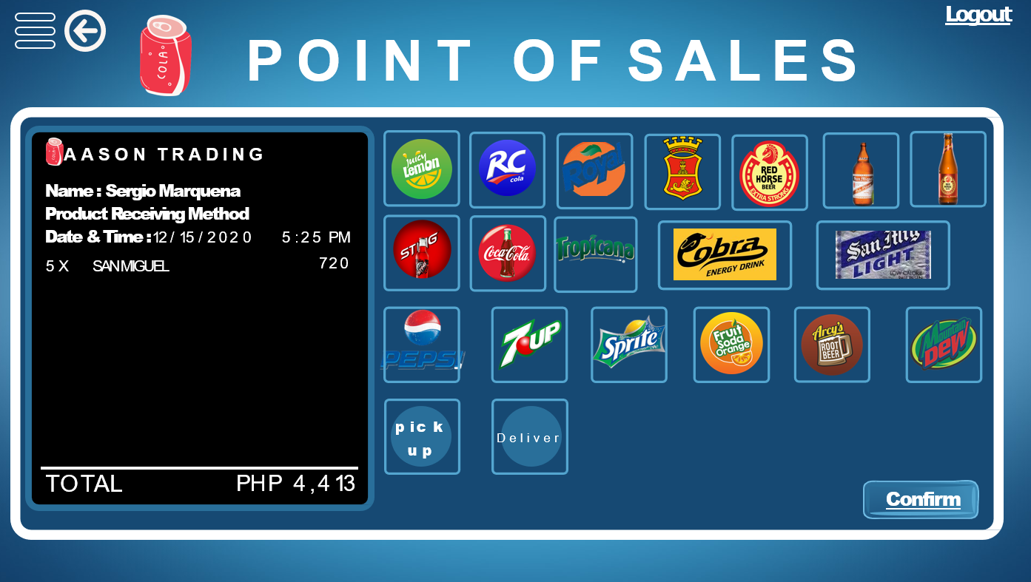

Figure 49. Add Sales Page

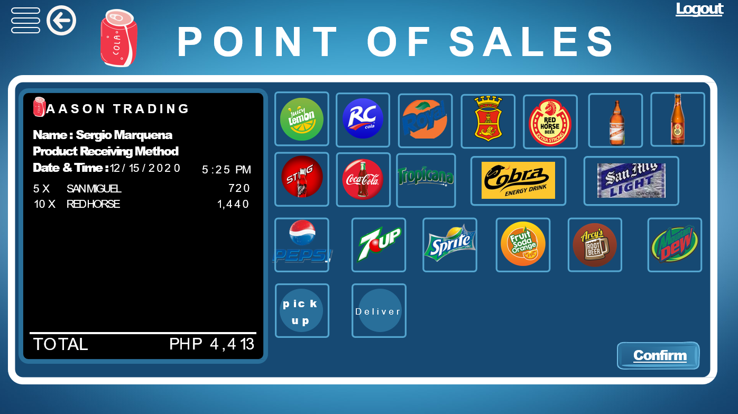

Figure 50. Add Sales Page

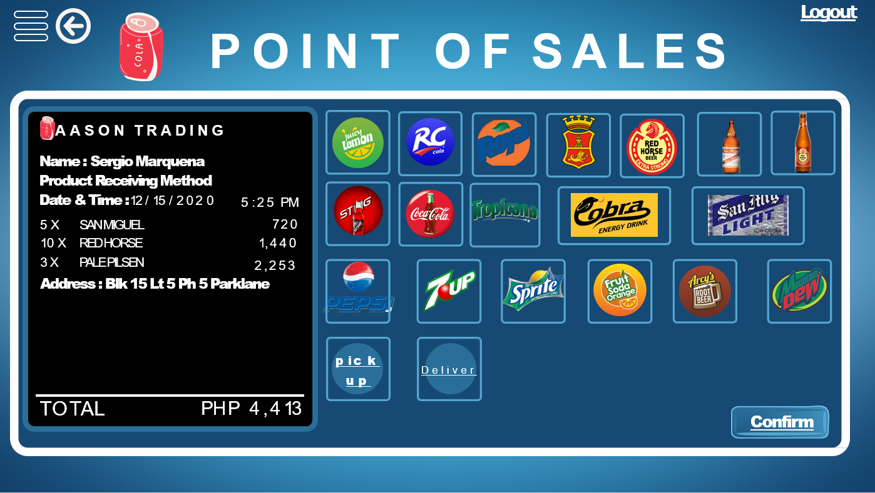

Figure 51. Add Sales Page

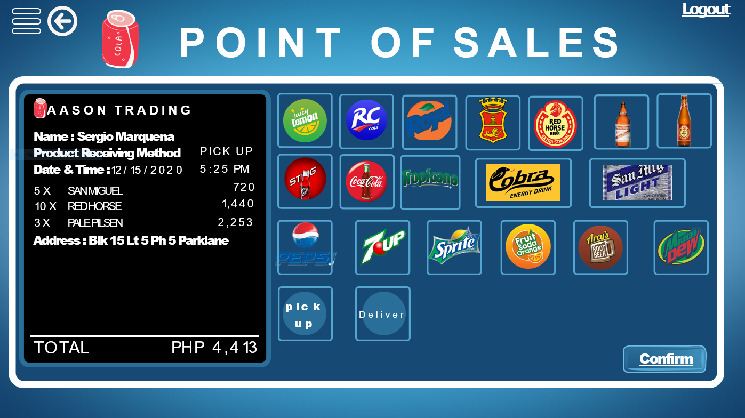

Figure 52. Add Sales Page

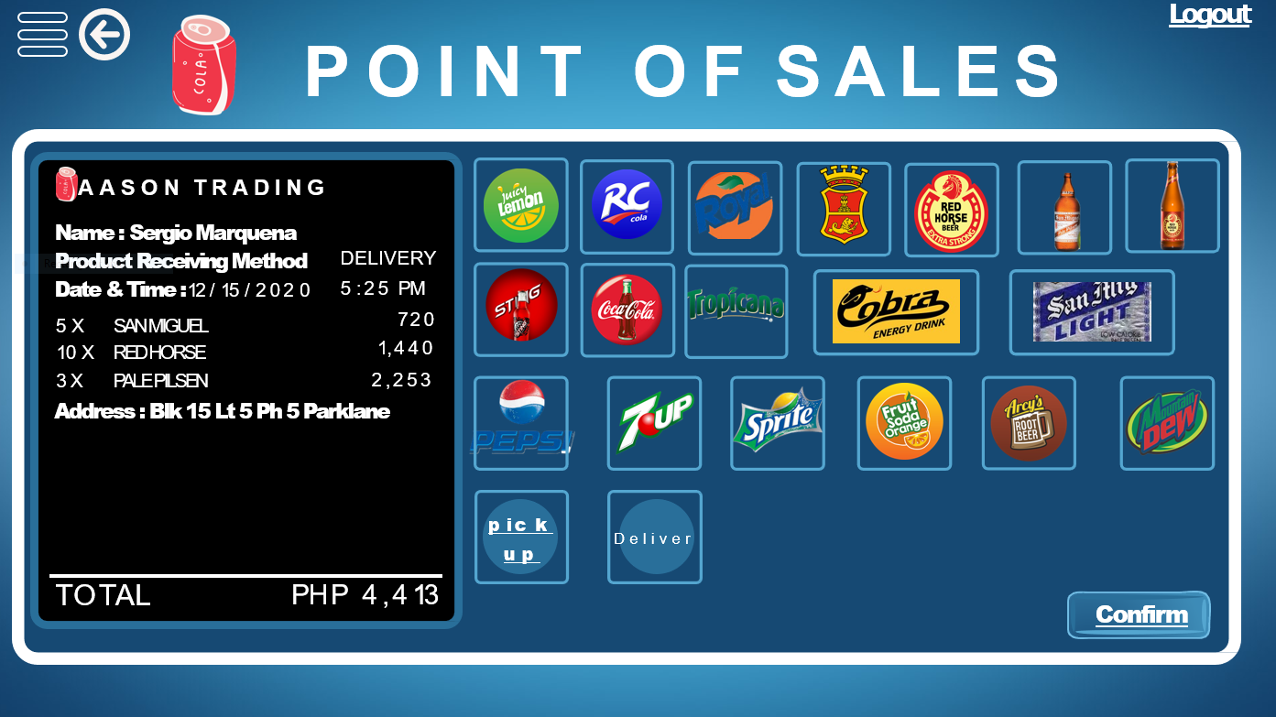

Figure 53. Add Sales Page

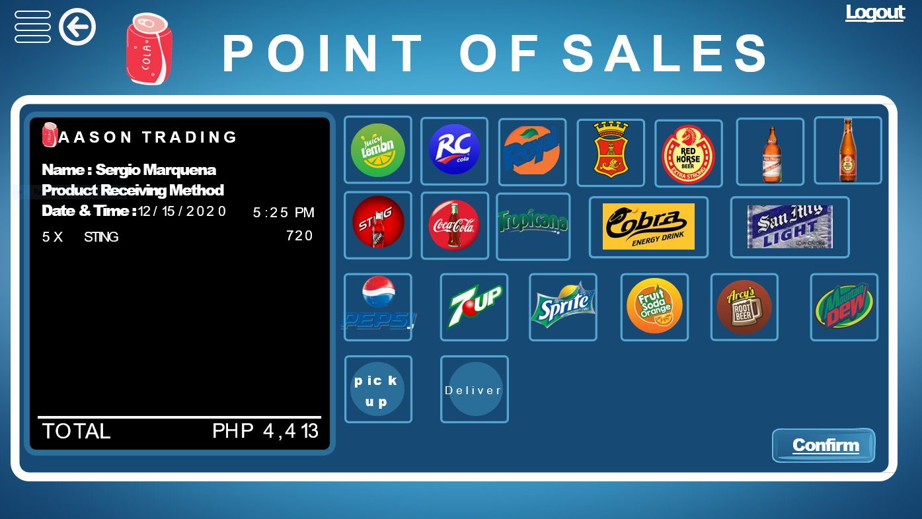

Figure 54. Add Sales Page

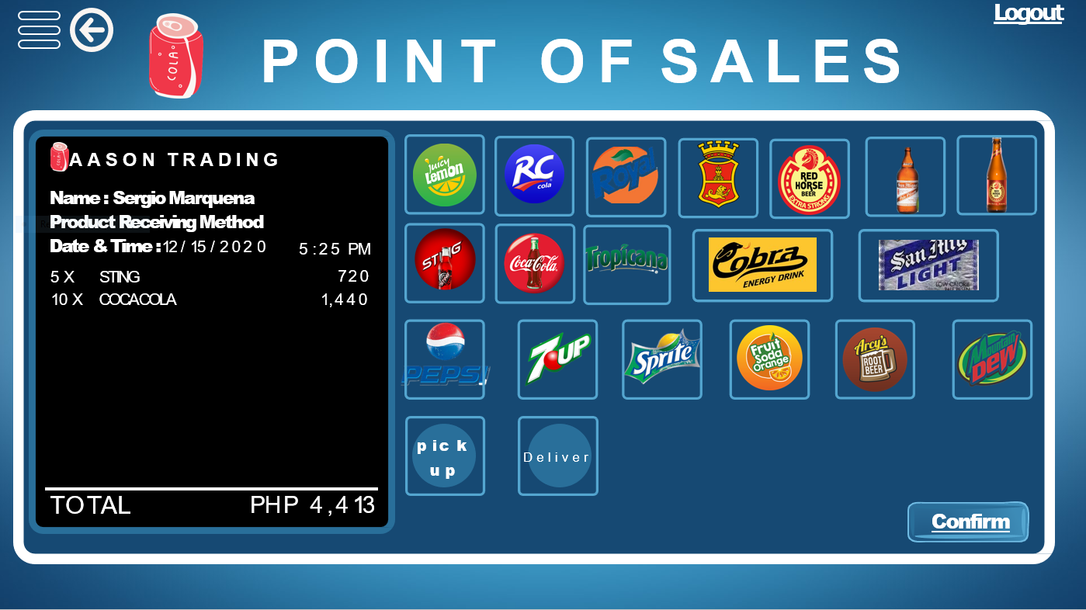

Figure 55. Add Sales Page

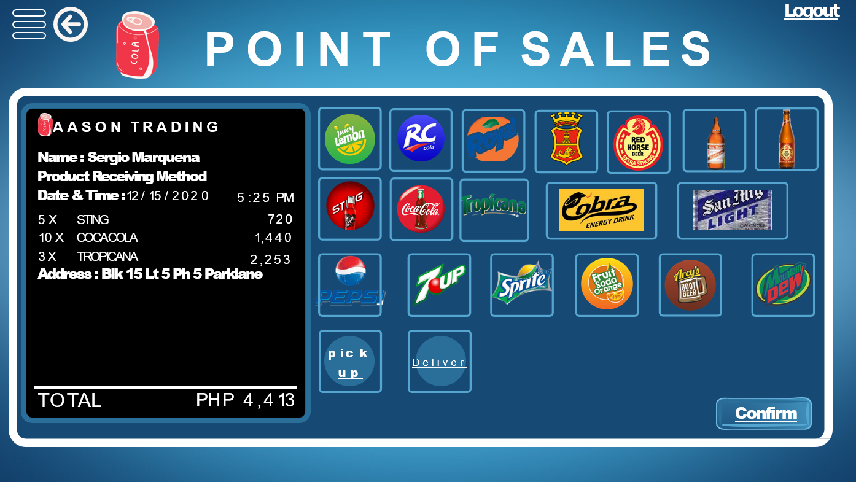

Figure 56. Add Sales Page

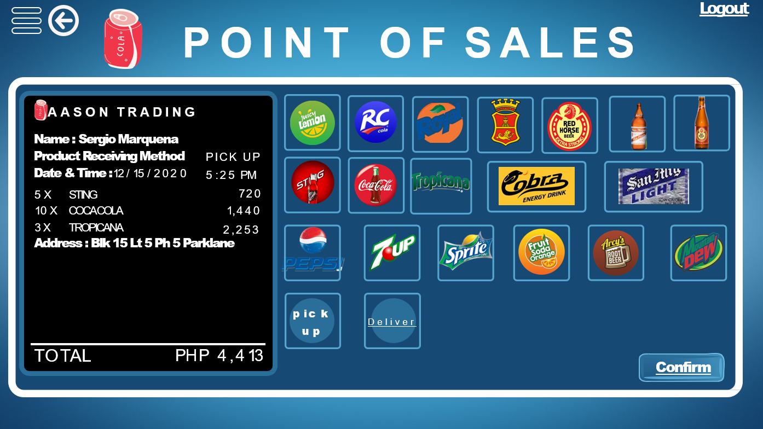

Figure 57. Add Sales Page

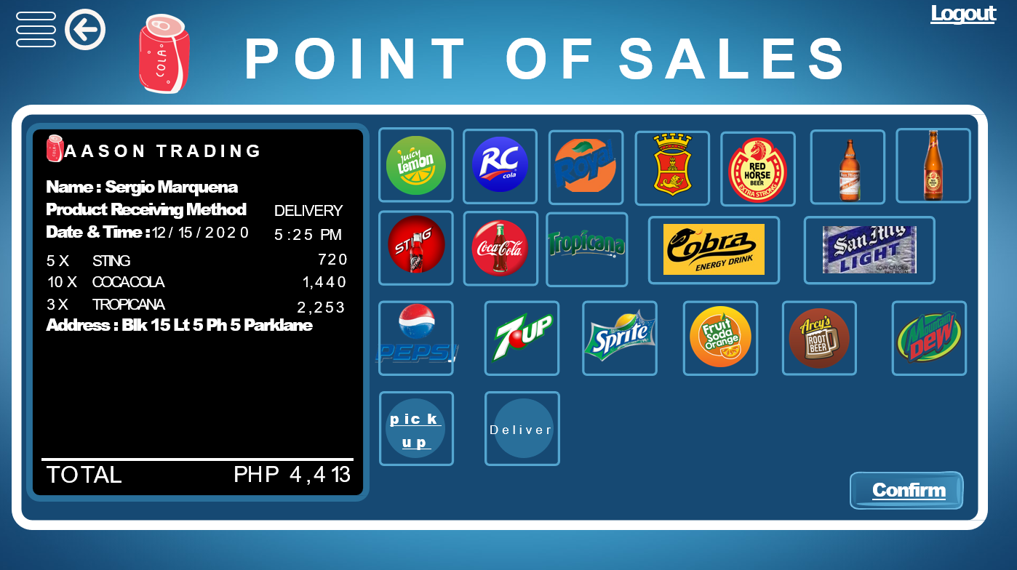

Figure 58. Add Sales Page

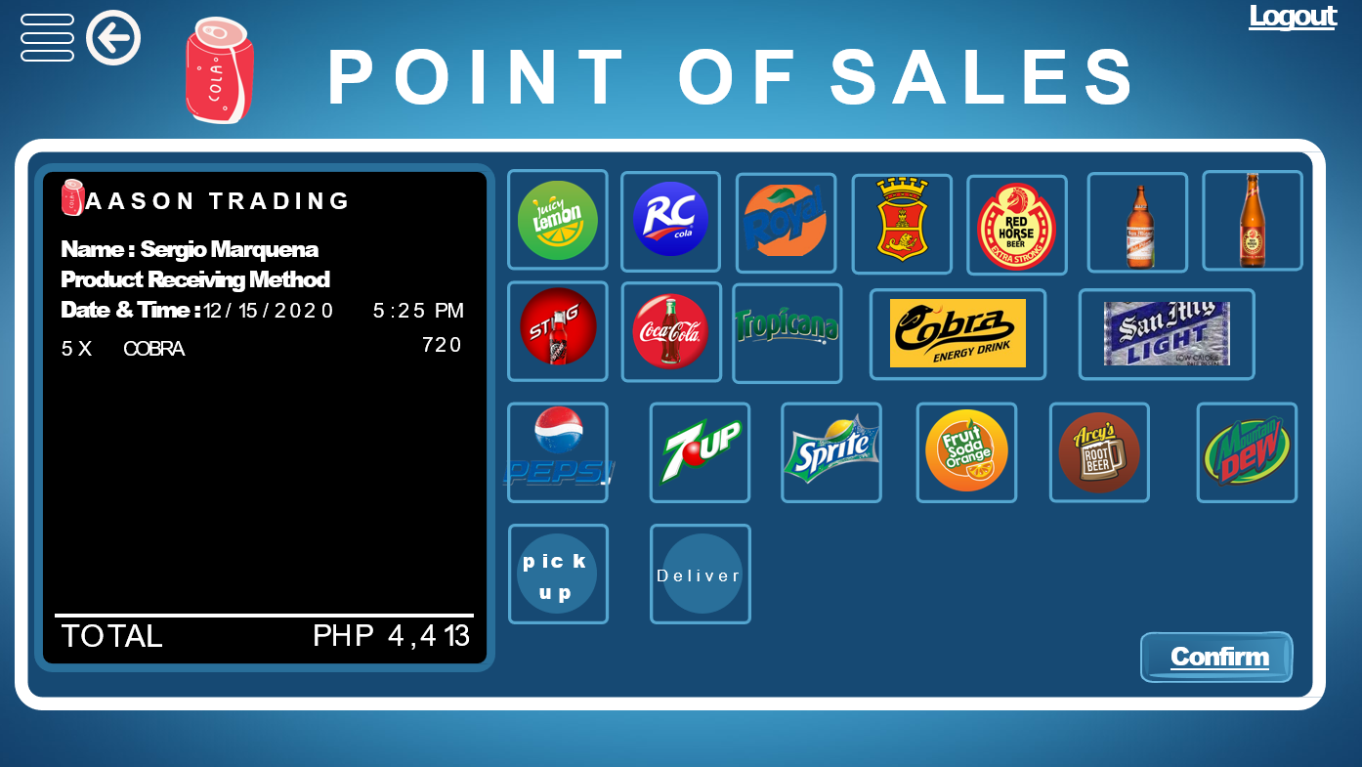

Figure 59. Add Sales Page 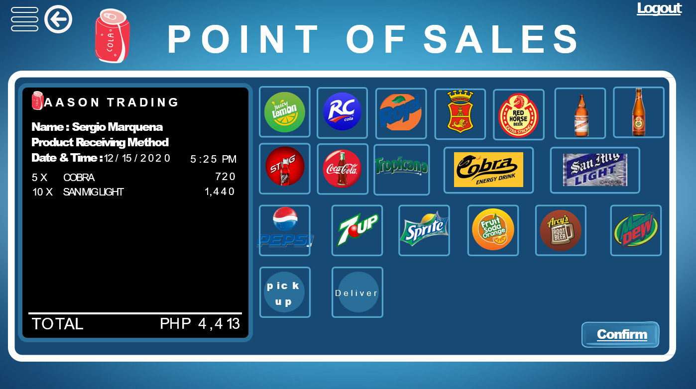

Figure 60. Add Sales Page

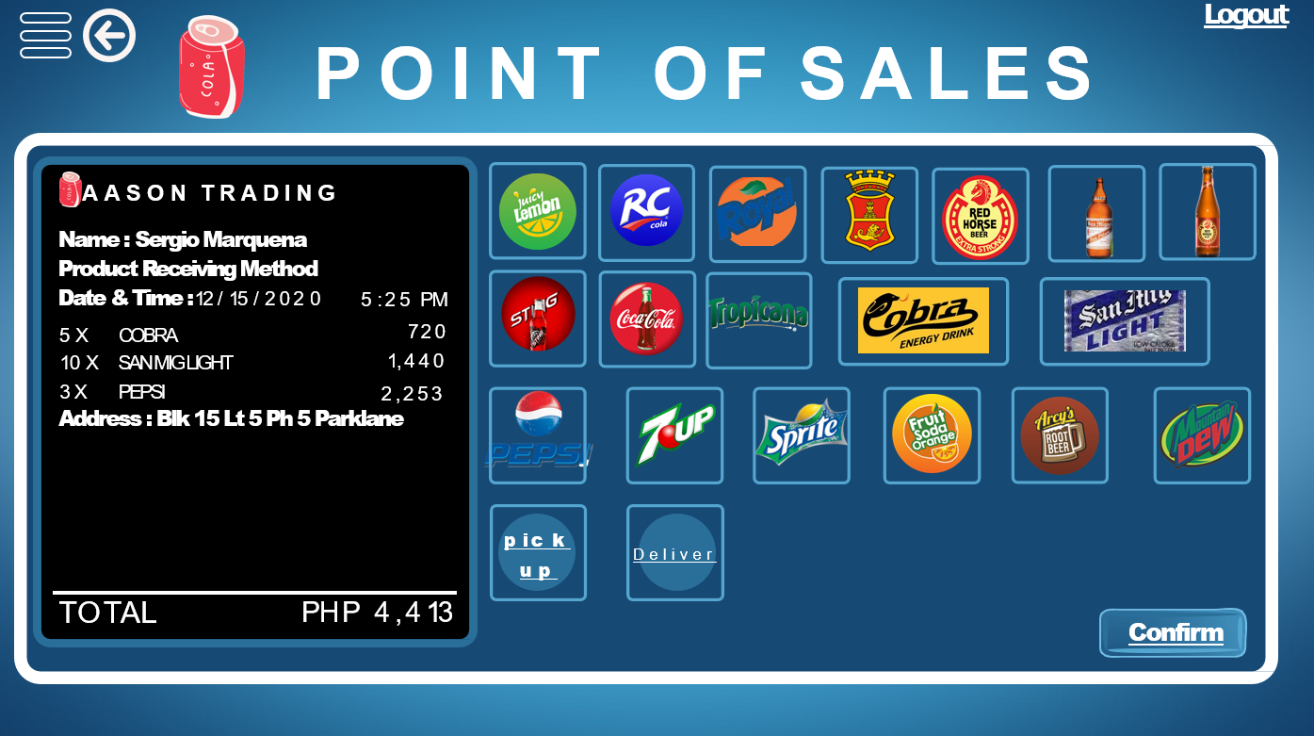

Figure 61. Add Sales Page

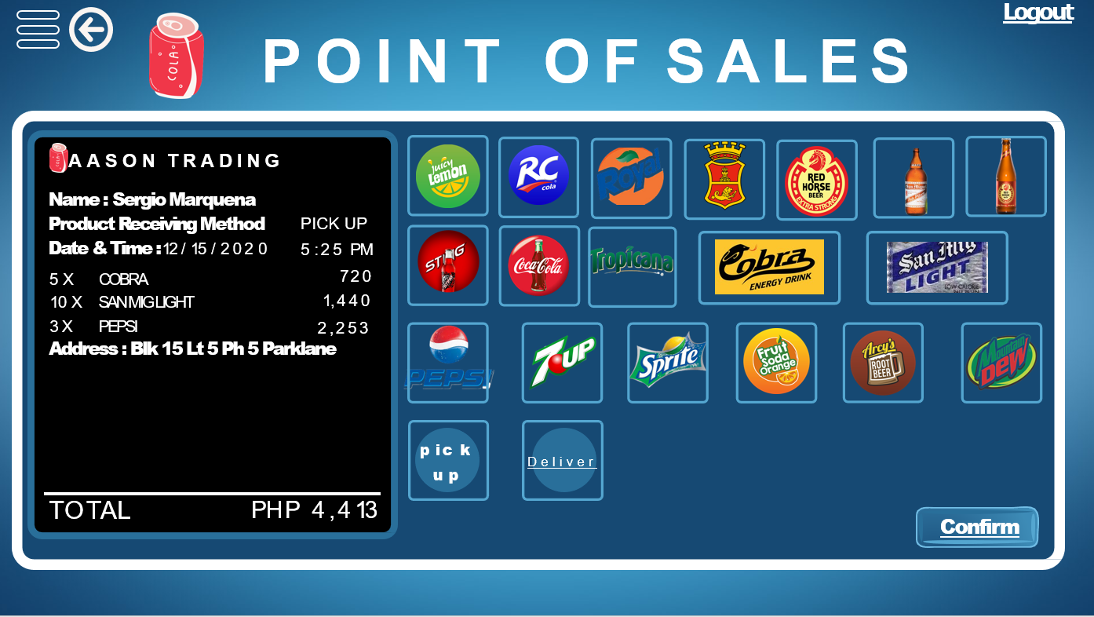

Figure 62. Add Sales Page

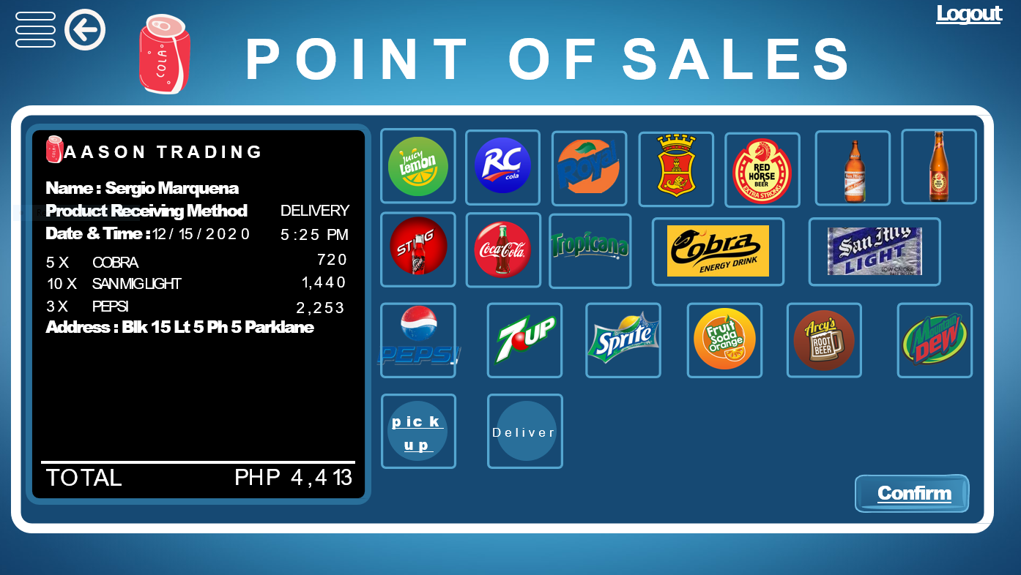

Figure 63. Add Sales Page

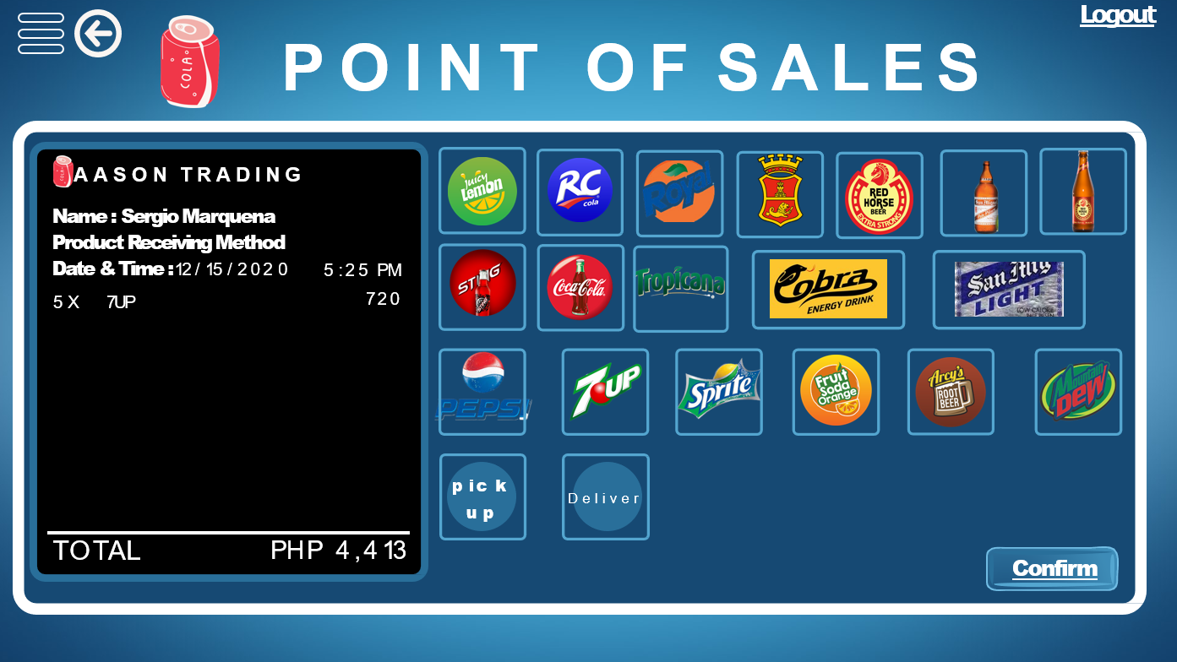

Figure 64. Add Sales Page

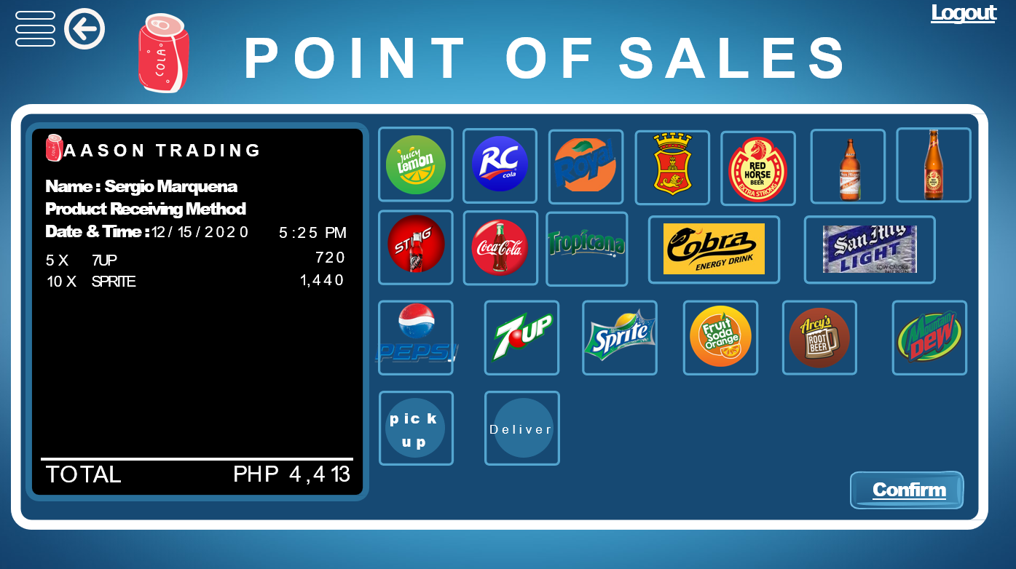

Figure 65. Add Sales Page

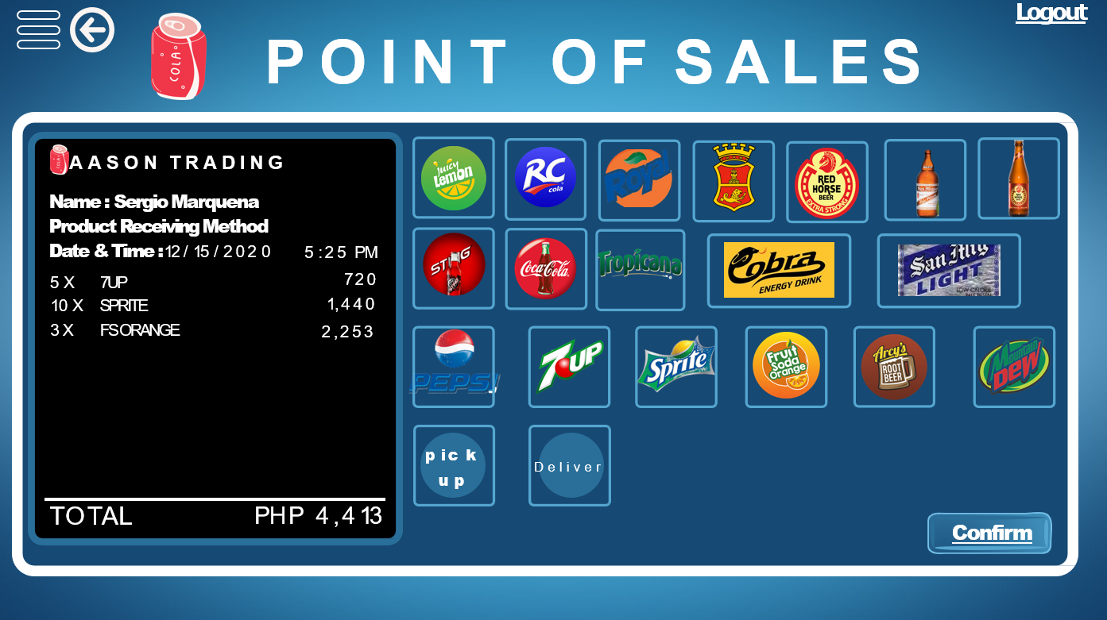

Figure 66. Add Sales Page 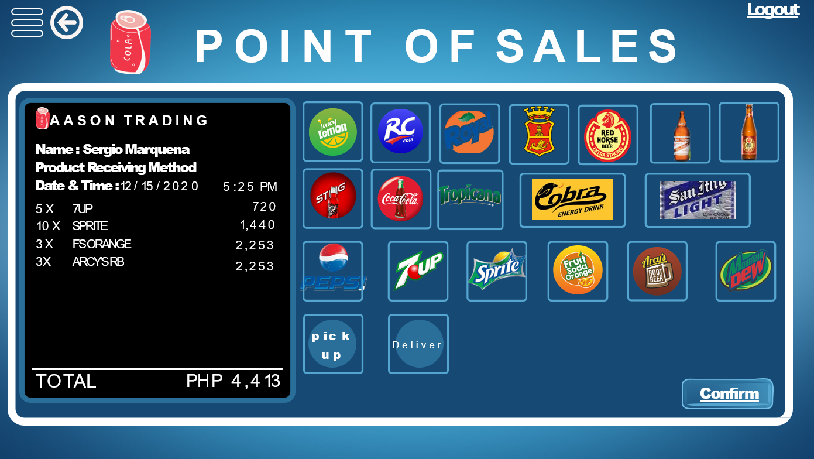

Figure 67. Add Sales Page

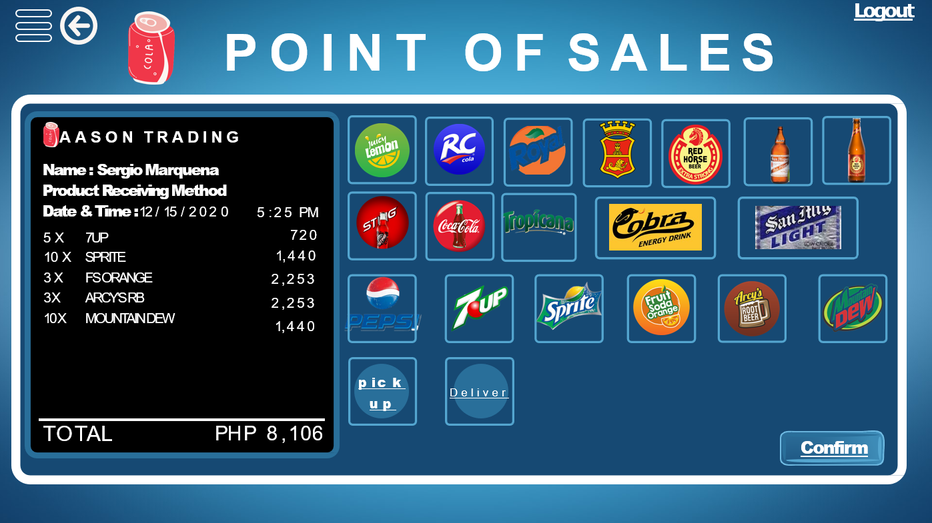

Figure 68. Add Sales Page 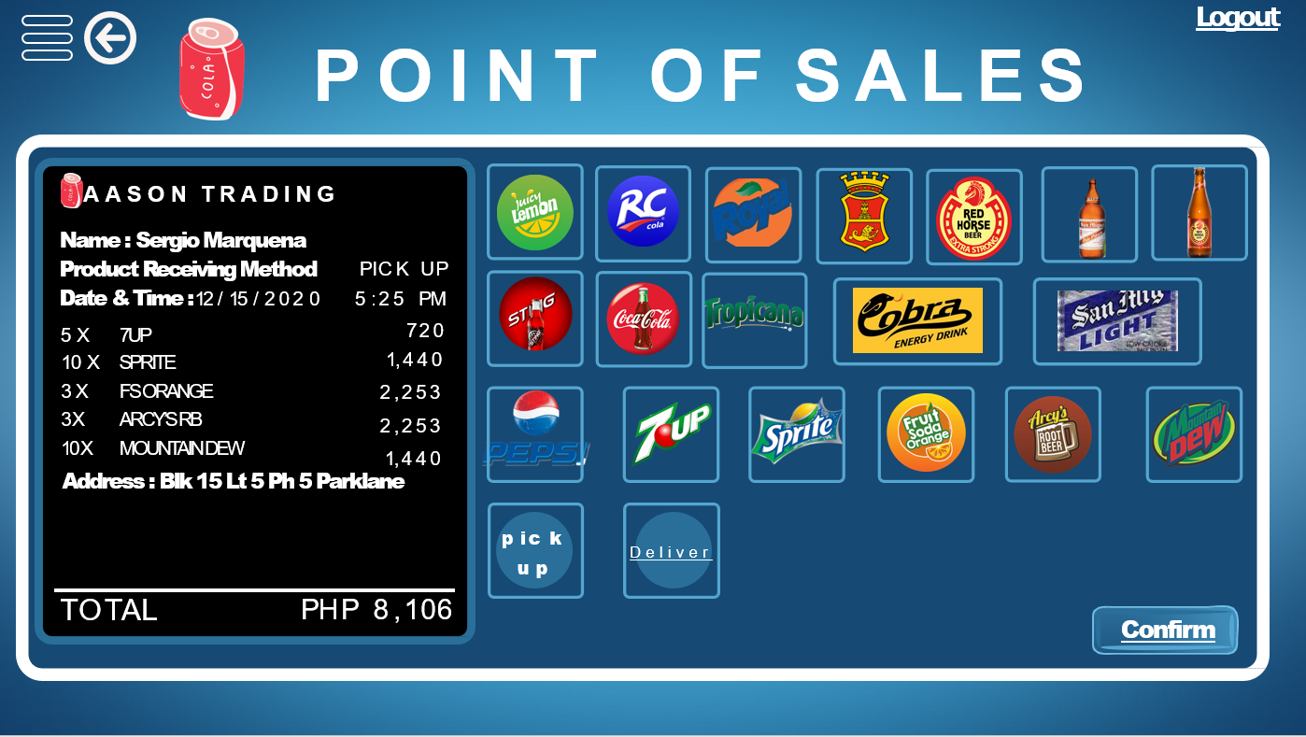

Figure 69. Add Sales Page

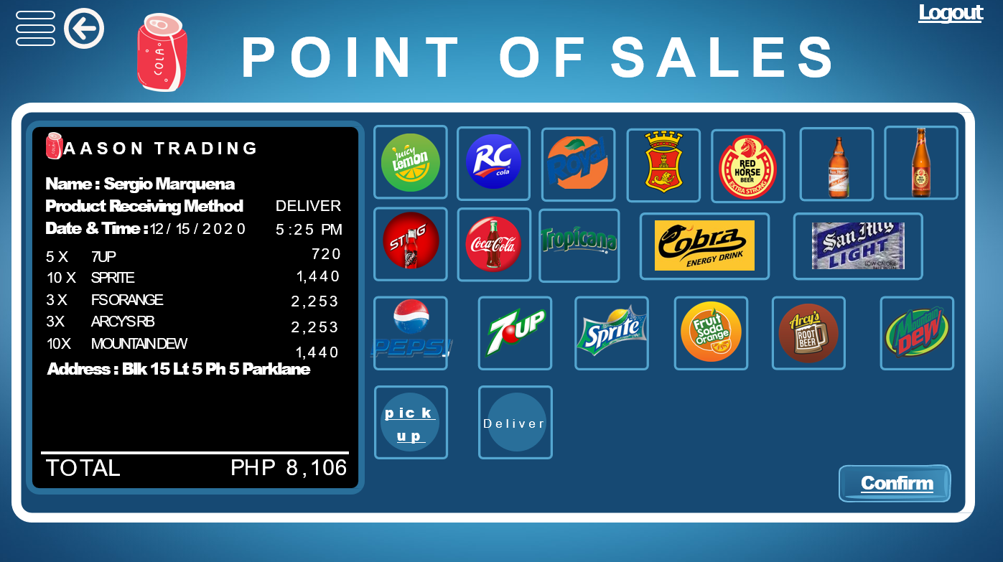

Figure 70. Point of Sales Confirmation Page

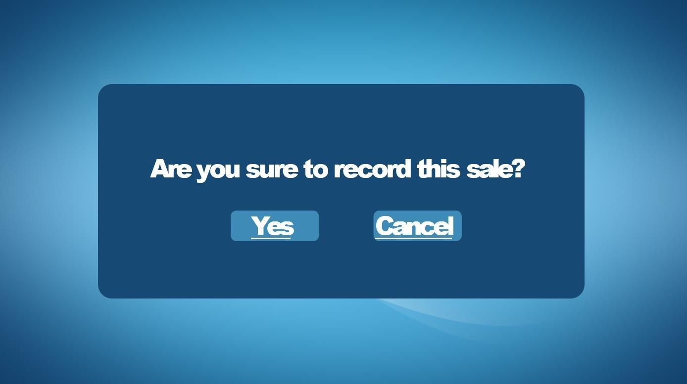

Figure 71. Updated Real Time Record of Sales Page

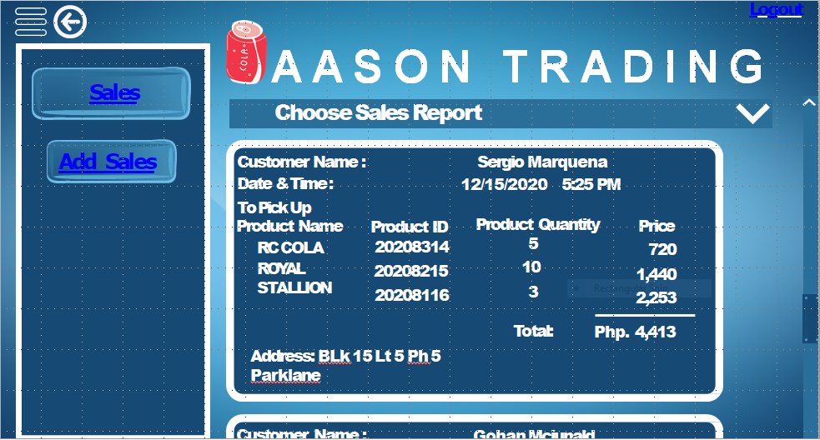

Figure 72. Updated Real Time Record of Sales Page

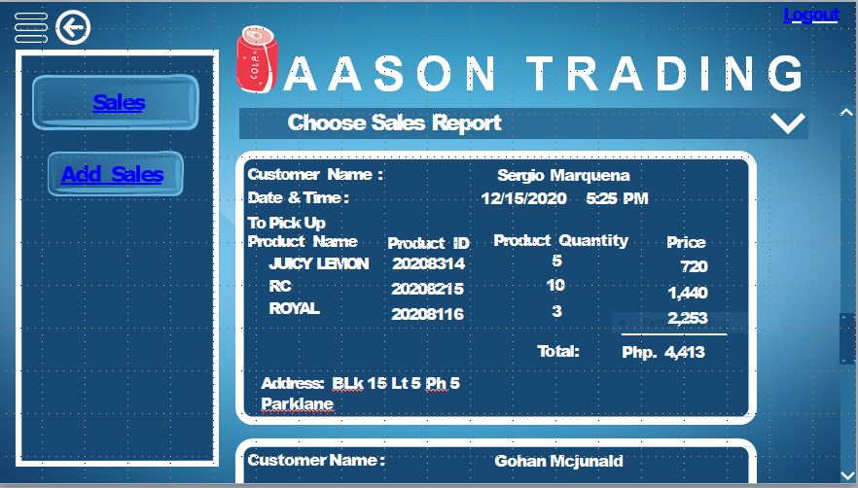

Figure 73. Updated Real Time Record of Sales Page

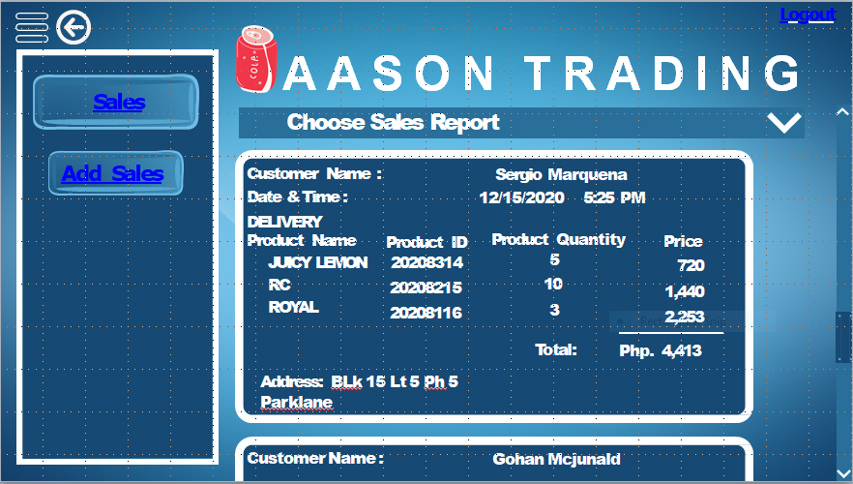

Figure 74. Updated Real Time Record of Sales Page

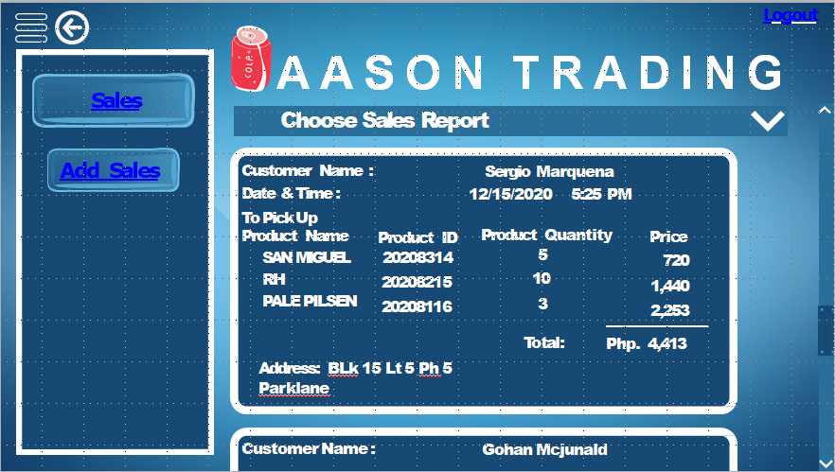

Figure 75. Updated Real Time Record of Sales Page

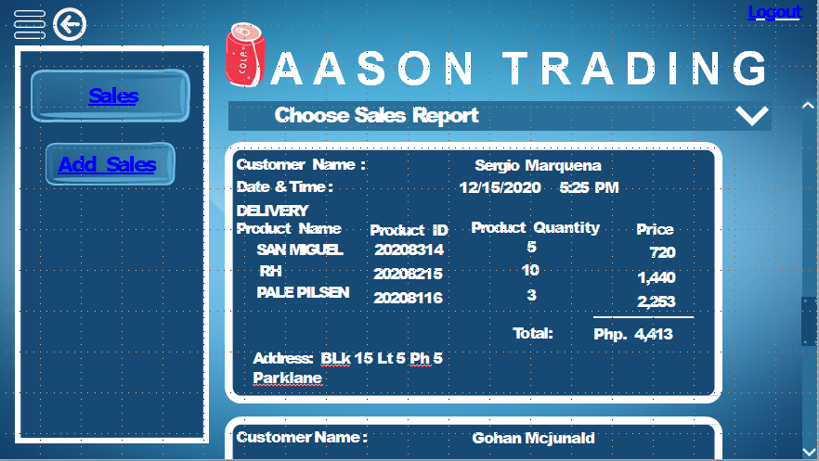

Figure 76. Updated Real Time Record of Sales Page

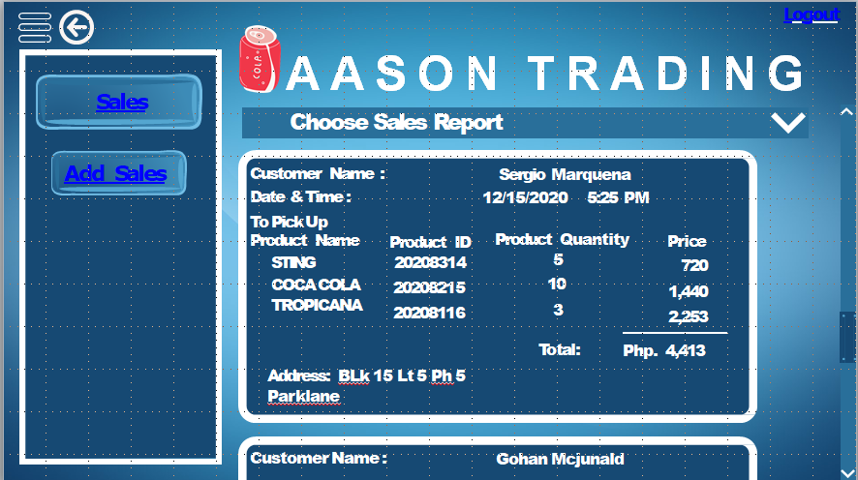

Figure 77. Updated Real Time Record of Sales Page

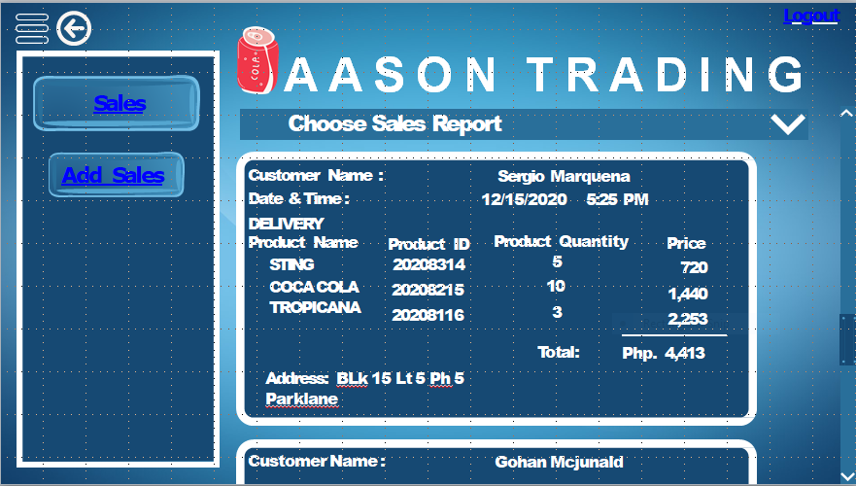

Figure 78. Updated Real Time Record of Sales Page

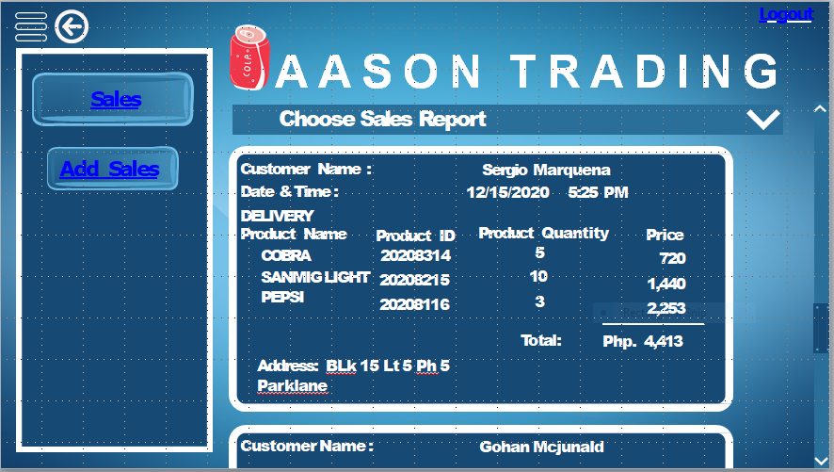

Figure 79. Updated Real Time Record of Sales Page

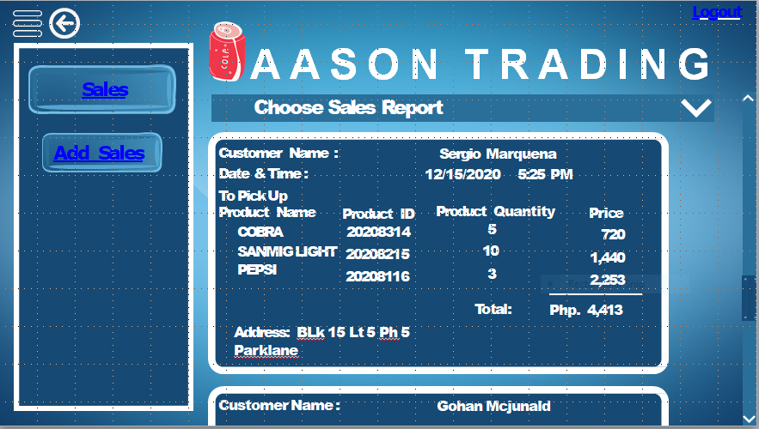

Figure 80. Updated Real Time Record of Sales Page

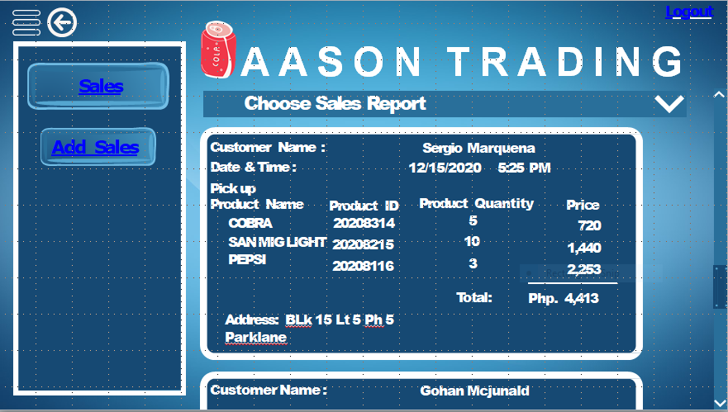

Figure 81. Updated Real Time Record of Sales Page

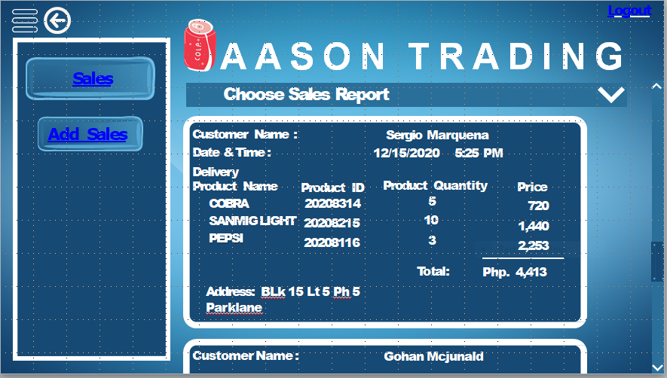

Figure 82. Updated Real Time Record of Sales Page

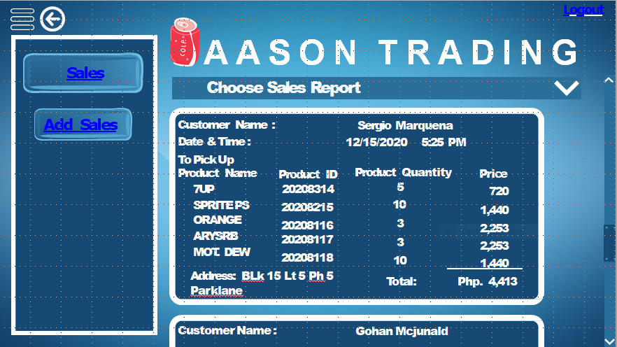

Figure 83. Updated Real Time Record of Sales Page

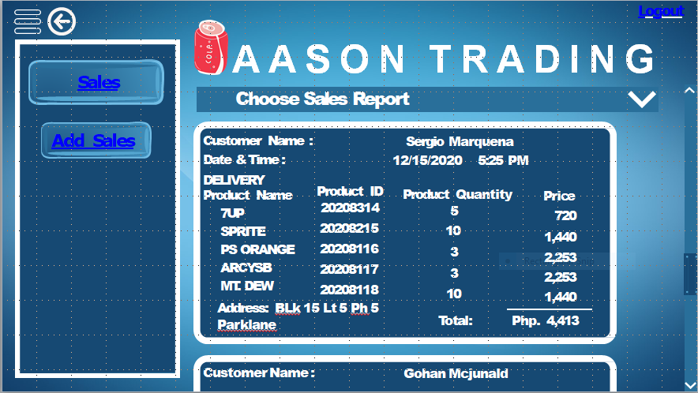

Figure 84. Updated Real Time Record of Sales Page



Figure 85. Sales Report Drop Down Page

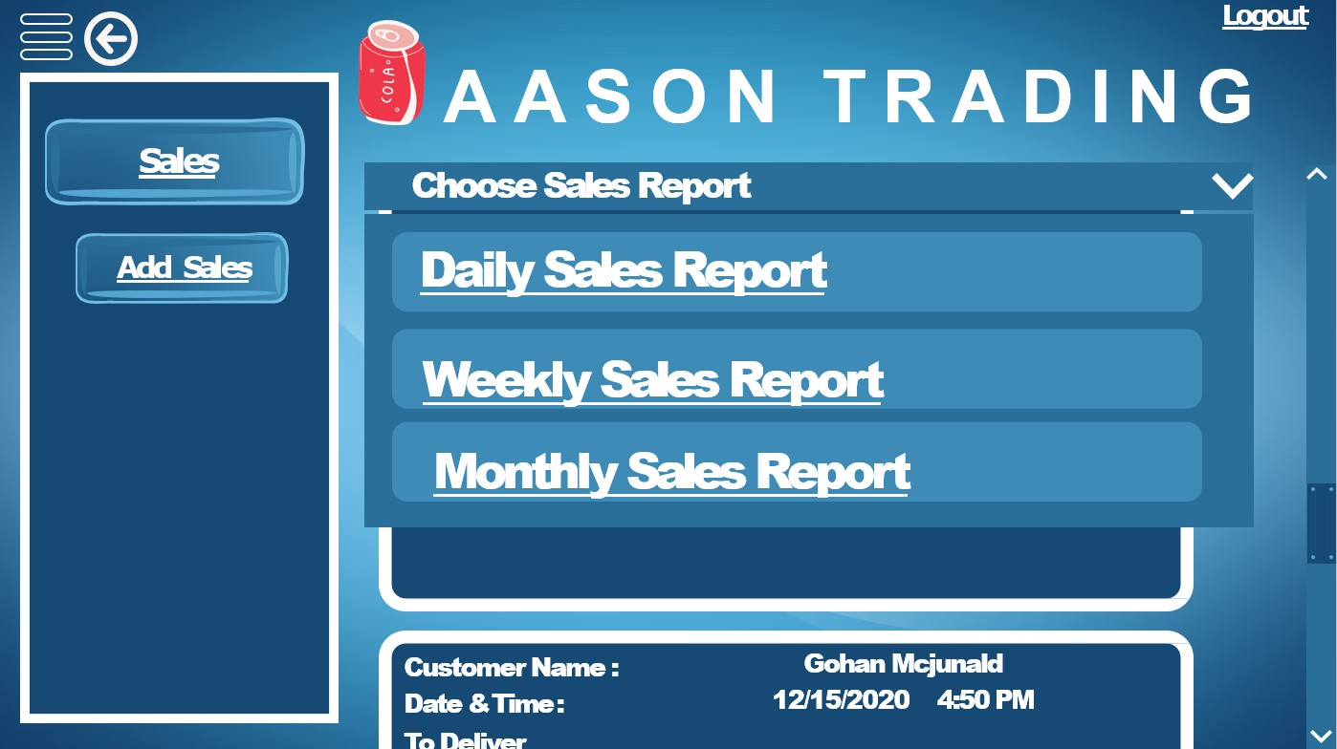

Figure 86. Daily Sales Report Page

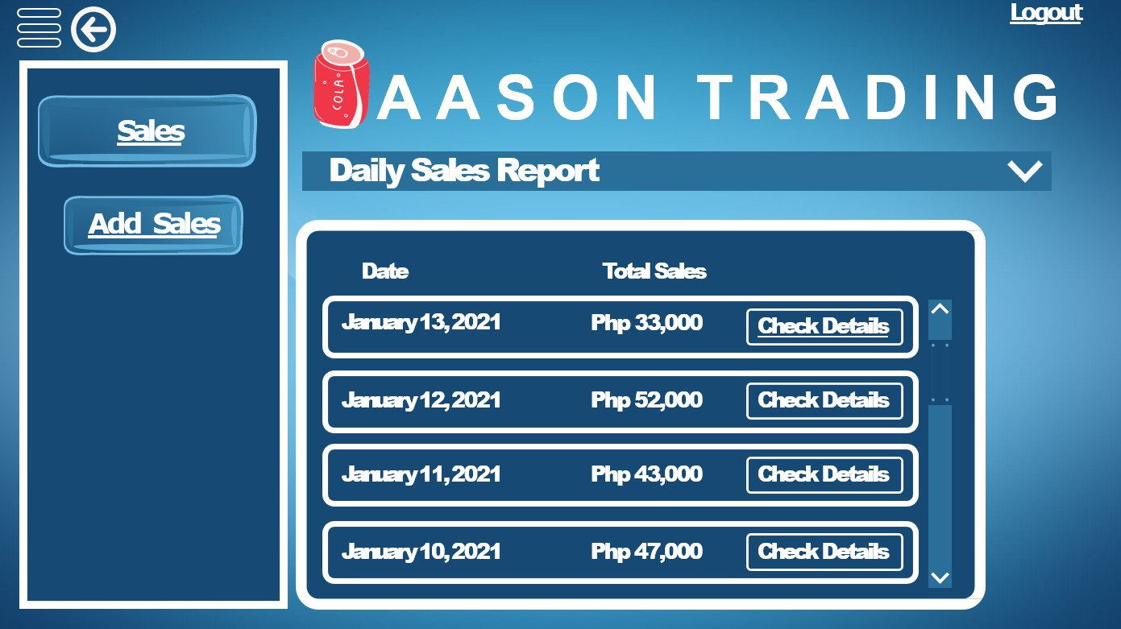

Figure 87. Check Details of Daily Sales Page

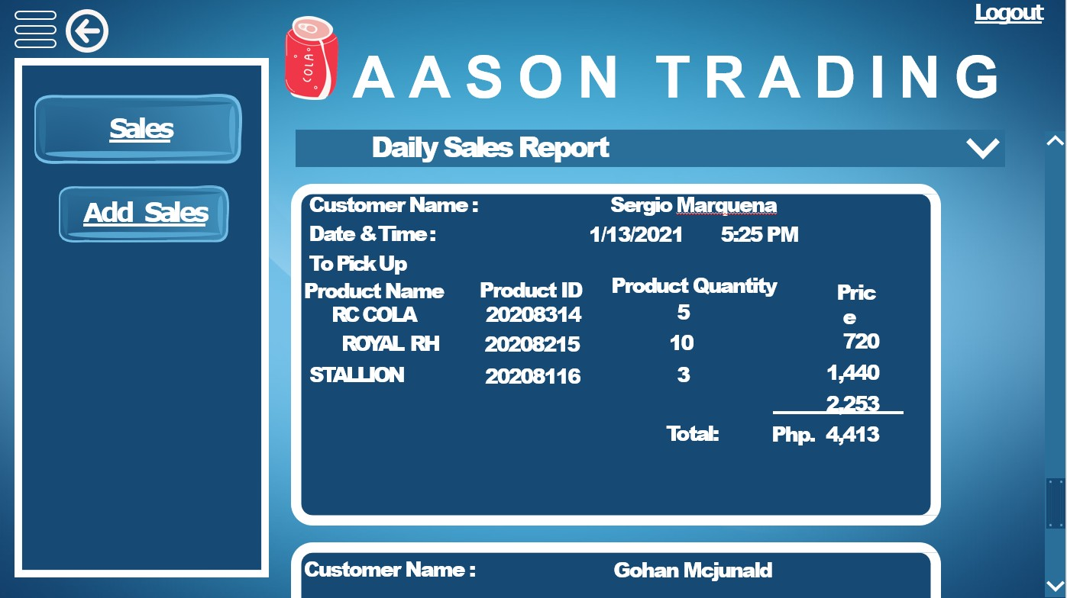

Figure 88. Weekly Sales Report Page

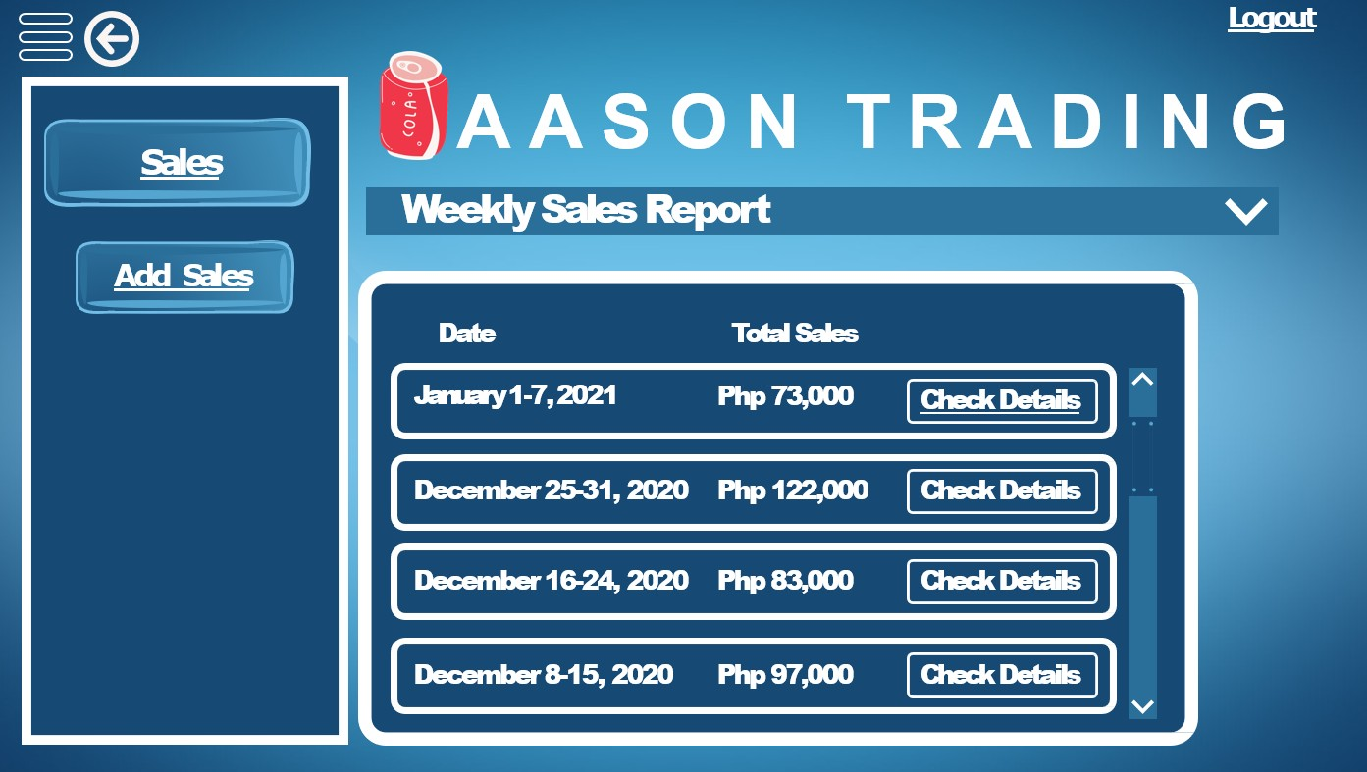

Figure 89. Check Details of Weekly Sales Page

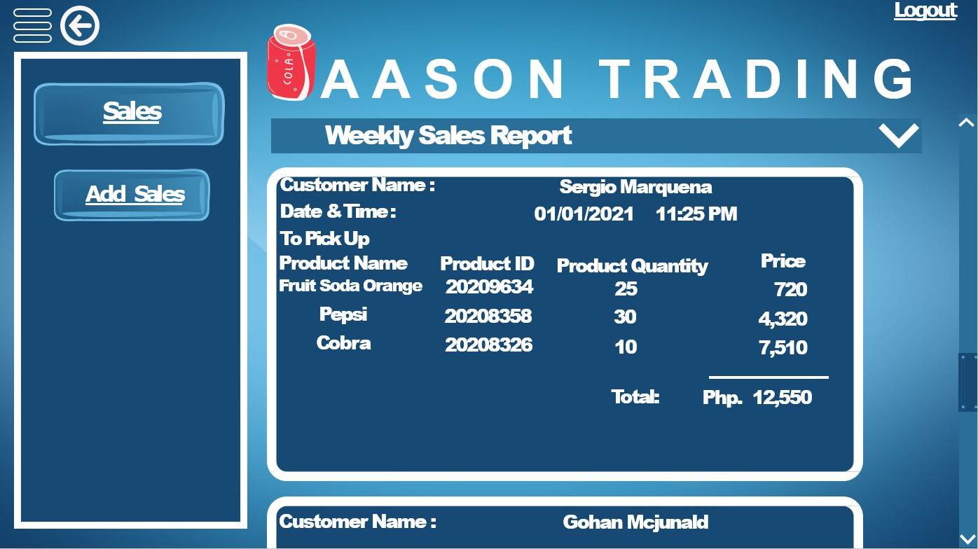

Figure 90. Monthly Sales Report Page

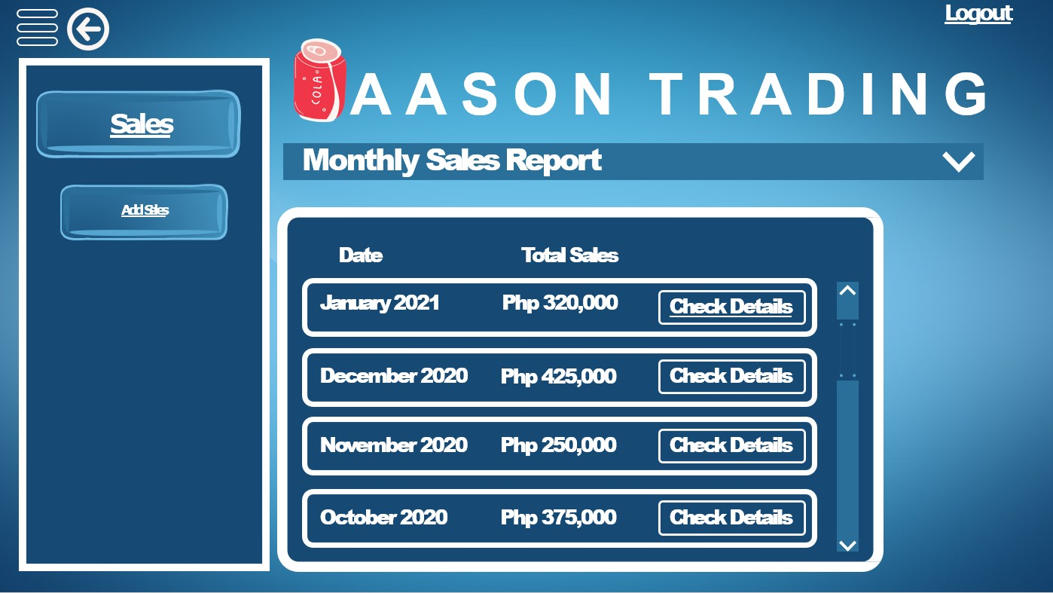

Figure 91. Check Details of Monthly Sales Page

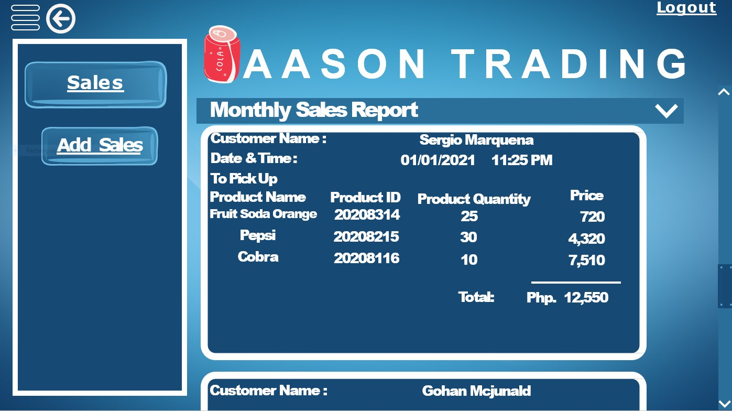

# Appendix I



**RONQUILLO, MARK R.**

BLK 106 LOT 37 PHASE 4 MARY CRIS COMPLEX PASCAM II GENERAL TRIAS CAVITE

0955-288-6402

[mrk.ronquillo031@gmail.com](mailto:mrk.ronquillo031@gmail.com)

# PERSONAL DATA

DATE OF BIRTH : January 31, 2000 PLACE OF BIRTH : Manila

AGE : 20

CIVIL STATUS : Single

FATHER’S NAME : Ronquillo, Samuel D. OCCUPATION : Company Driver

MOTHER’S NAME : Ronquillo, Hilda R. OCCUPATION : Accountant

**EDUCATION**

TERTIARY Cavite State University - Imus Campus

LTO Compound, Palico 4, Imus City, Cavite City, Cavite (2018 – 2022)

SENIOR HIGH SCHOOL Emilio Aguinaldo College – Imus Cavite

Congressional East Ave, Burol Main, Dasmariñas, Cavite (2016 – 2018)

JUNIOR HIGH SCHOOL Dasmarinas National High School – Main Campus

Congressional South Avenue, Dasmariñas, Cavite (2015 – 2016)

Oxford Louise Academy of Dasmarinas Inc.

125 Don Placido Campos Avenue, Dasmariñas, Cavite (2012 – 2015)

ELEMENTARY Oxford Louise Academy of Dasmarinas Inc.

125 Don Placido Campos Avenue, Dasmariñas, Cavite (2010 – 2012)

Maranatha Christian Academy

Malagasang Rd, Malagasang 2D, Imus, 4103 Cavite

(2006 – 2012)

# Appendix J

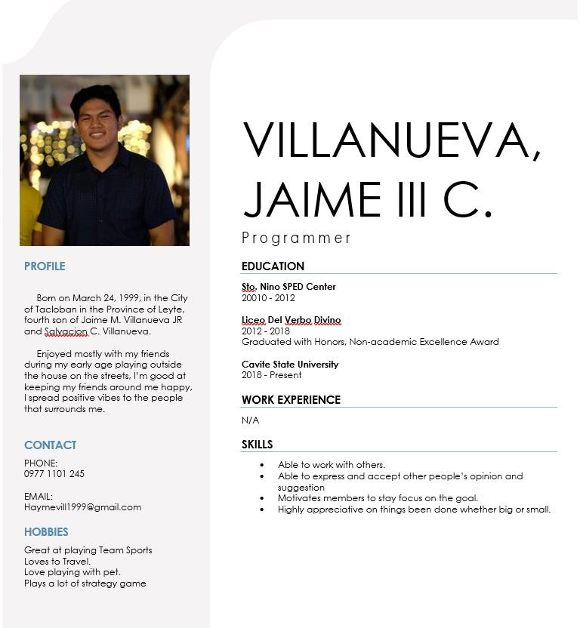

**Appendix K**

